

**INDEX**

| **S. NO.** | **PAGE NO.** | **DATE** | **SUBJECT** | **SIGNATURE** |
| --- | --- | --- | --- | --- |
| 1. | 3-16 | 16.04.2022 | Assignments |  |
| 2. | 17-37 | 08.02.2022 | HackerRank 20 Regex Problems |  |
| 3. | 37-63 | 31.03.2022 | HackerRank Remaining Problems |  |
| 4. | 64 |  | Experiments |  |
| 5. | 65-67 | 10.01.2022 | Implementation of Lexical Analysis |  |
| 6. | 68-72 | 27.01.2022 | Regular Expression of nfa |  |
| 7. | 73-76 | 08.02.2022 | Conversion of nfa to dfa |  |
| 8. | 77-87 | 17.02.2022 | Left Factoring and Left Recursion |  |
| 9. | 86-95 | 22.02.2022 | Computation of First and Follow |  |
| 10. | 96-101 | 04.03.2022 | Predictive Parsing |  |
| 11. | 102-107 | 10.03.2022 | Shift Reduce Parsing |  |
| 12. | 108-110 | 17.03.2022 | Leading and Trailing |  |
| 13. | 111-119 | 24.03.2022 | Computation of LR(0) Items |  |
| 14. | 120-124 | 31.03.2022 | Intermediate Code generation - Postfix, Prefix |  |
| 15. | 125-128 | 31.03.2022 | Indirect - Quadruple,Triple, Indirect Triple |  |
| 16. | 129-131 | 07.04.2022 | Implementation of DAG |  |
| 17. | 132-139 | 07.04.2022 | Implementation of One Storage SLO-2 Allocation Strategies |  |

**ASSIGNMENTS**

**UNIT 1**

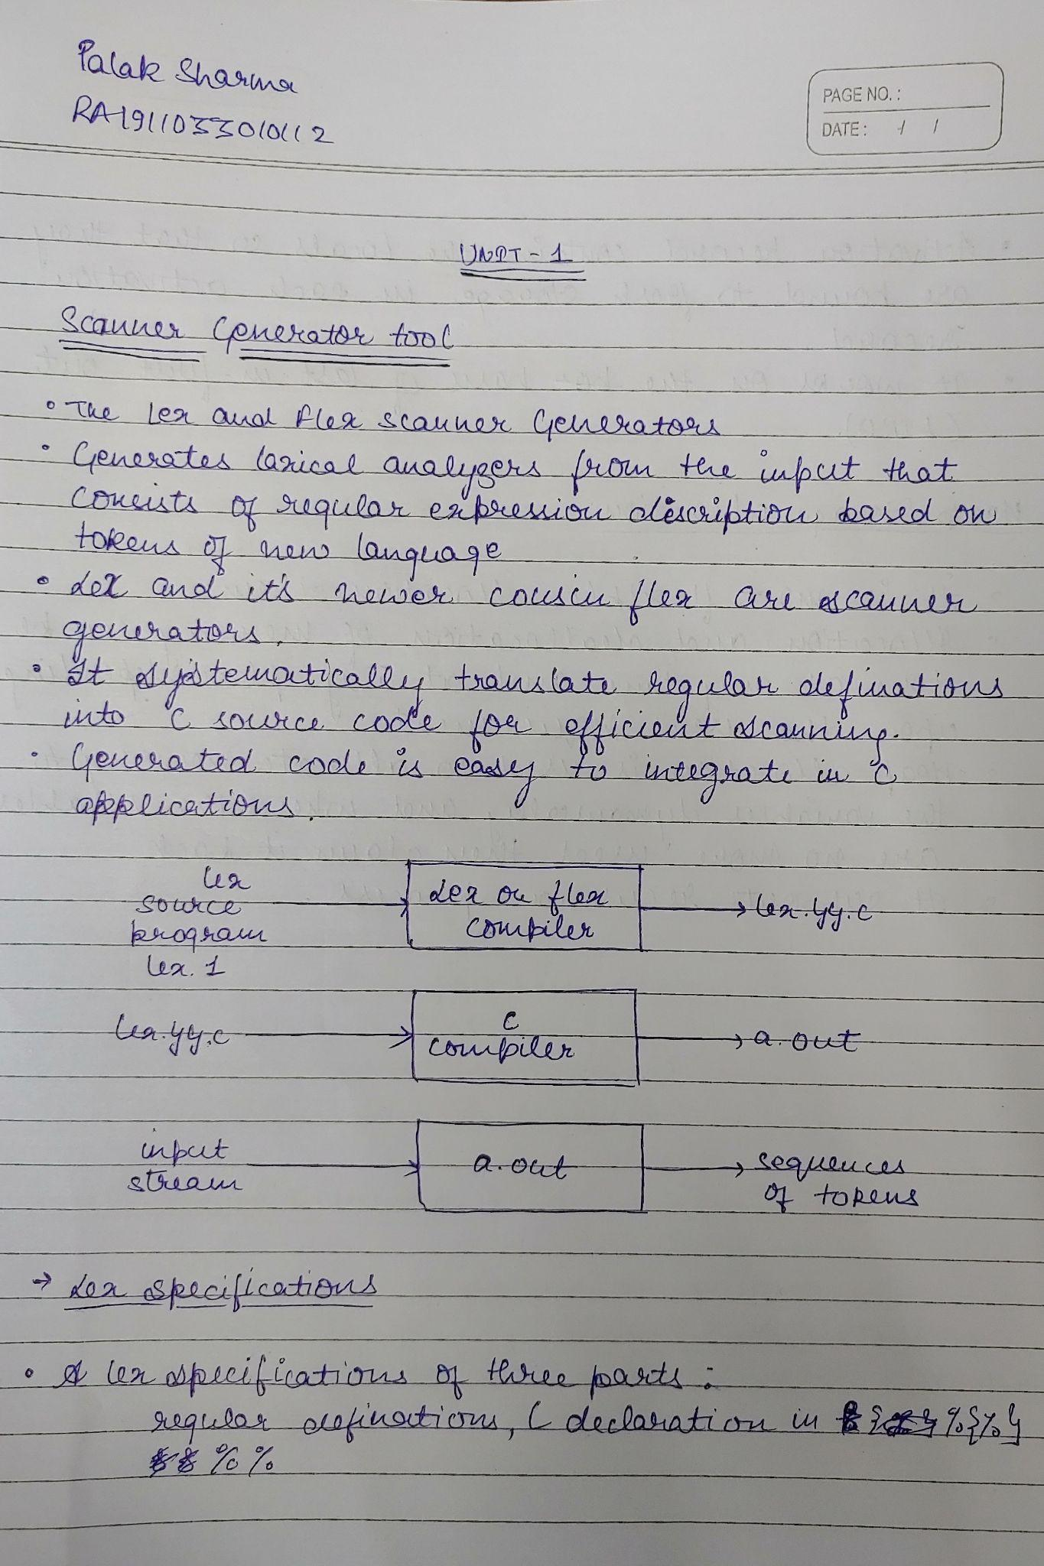

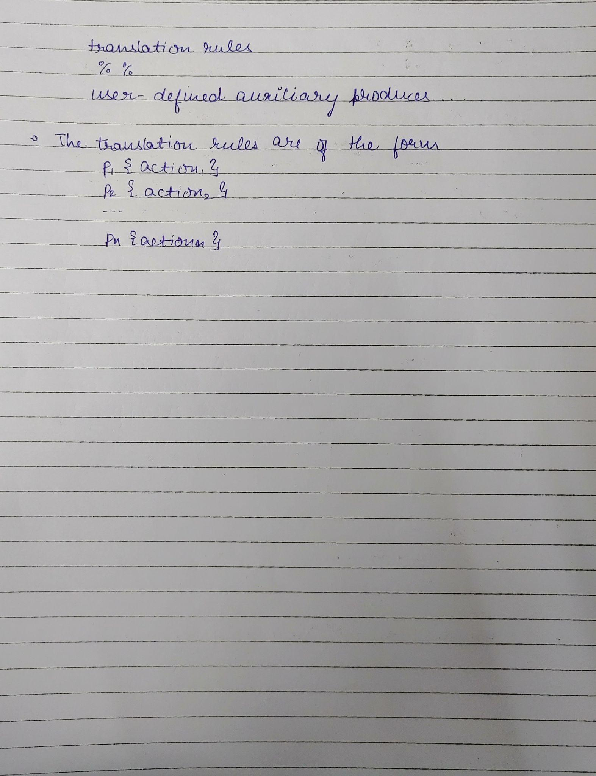

**UNIT 2 AND UNIT 3**

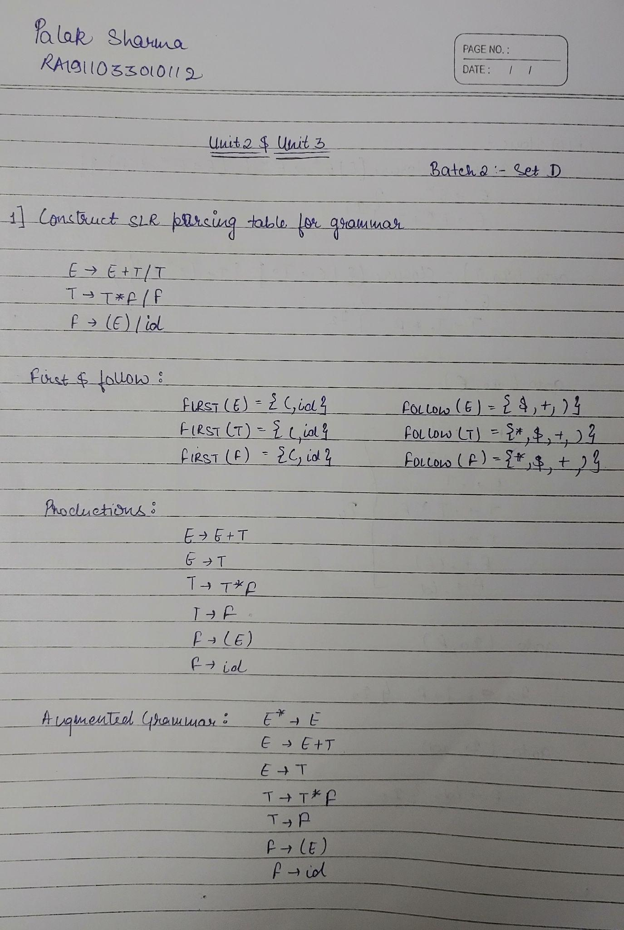

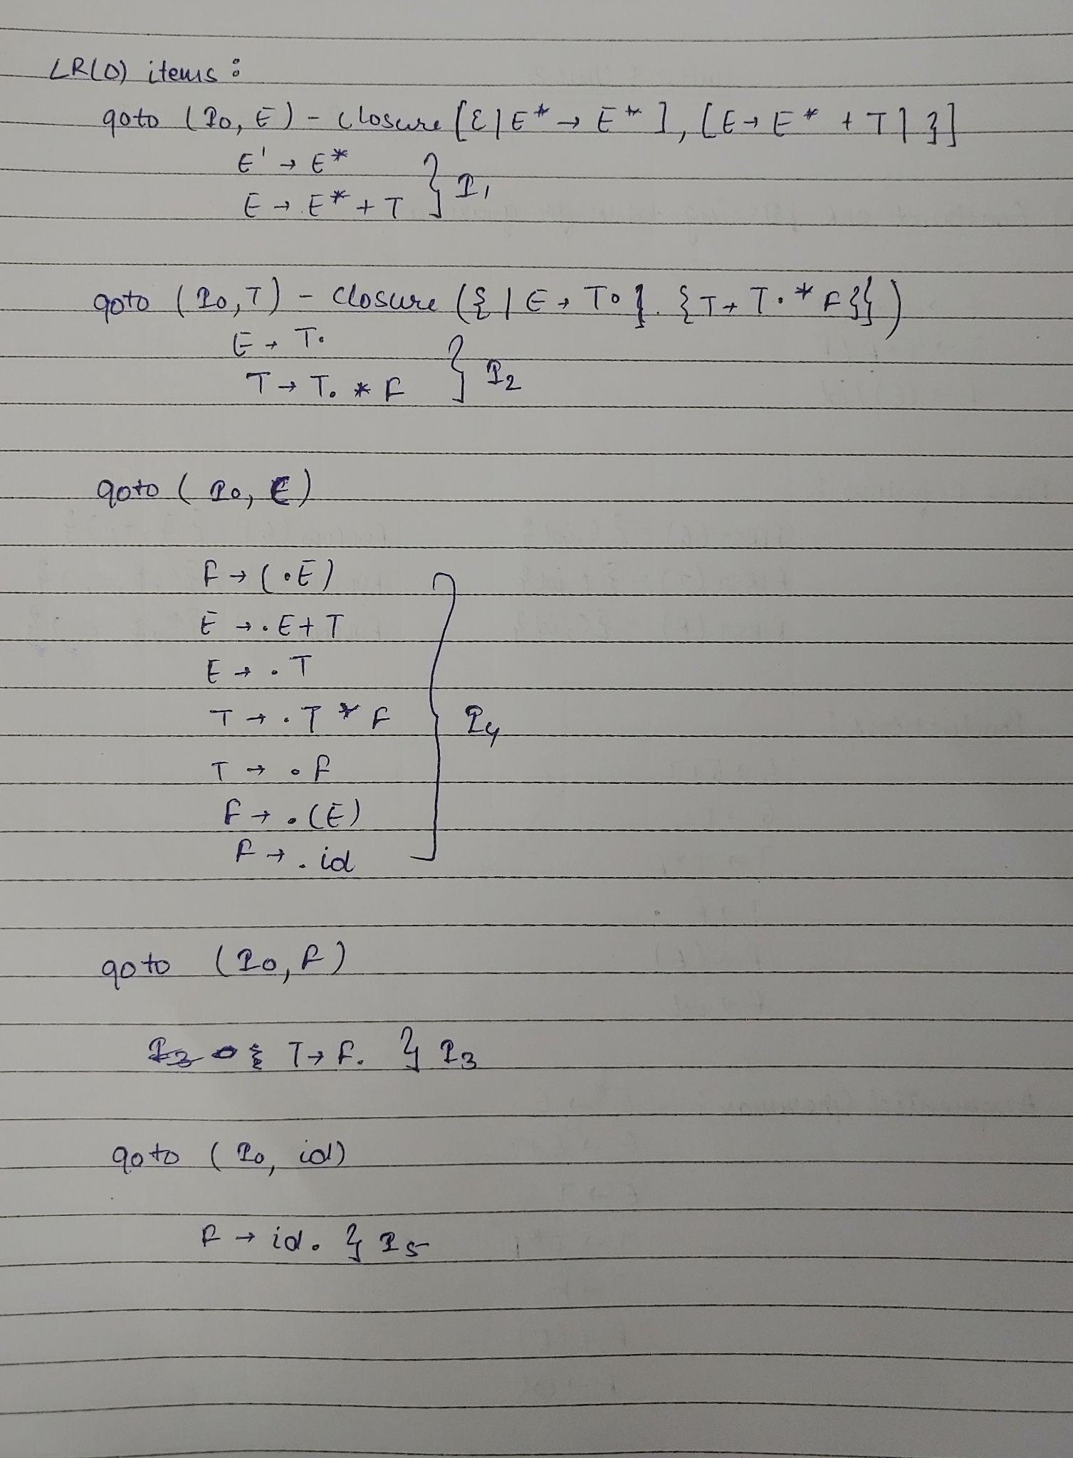

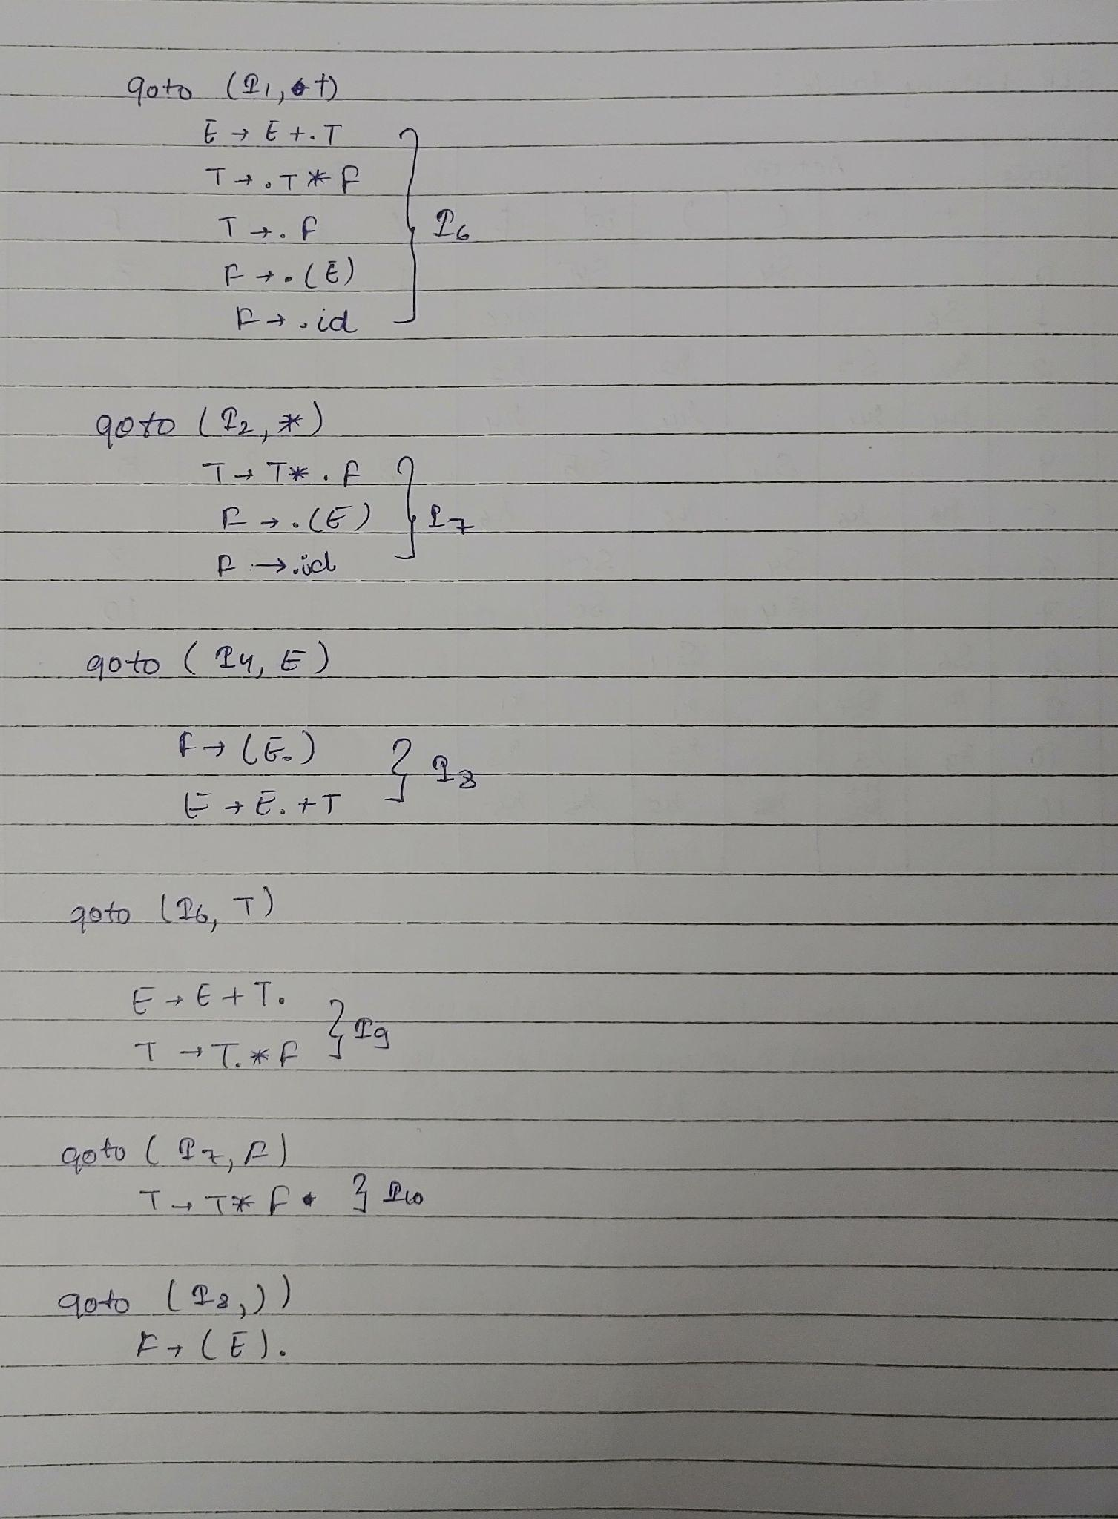

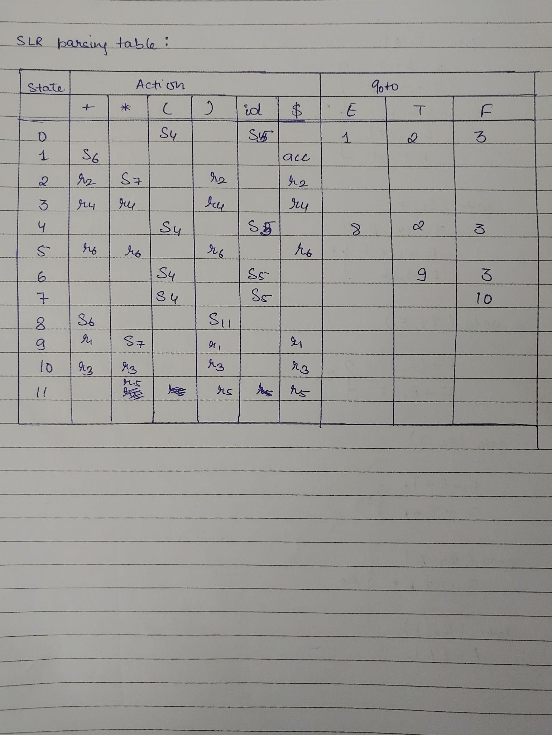

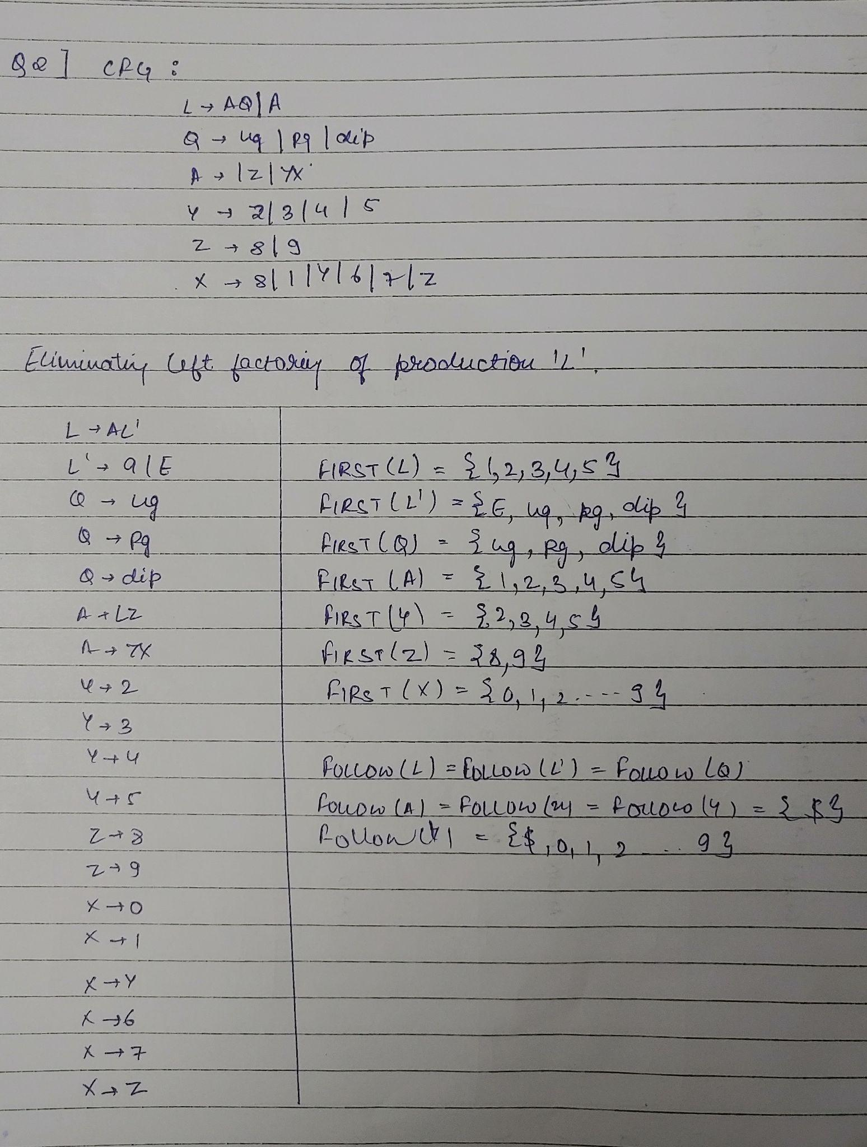

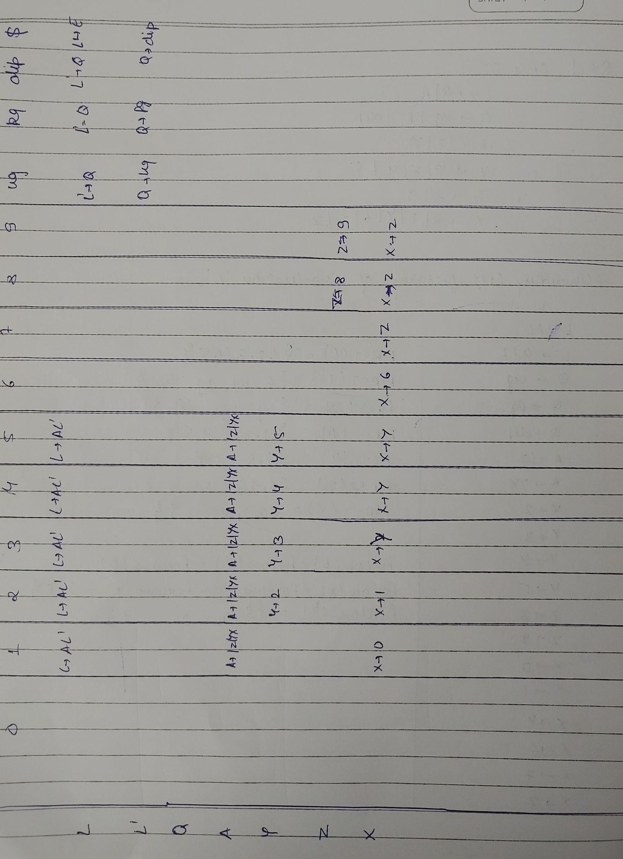

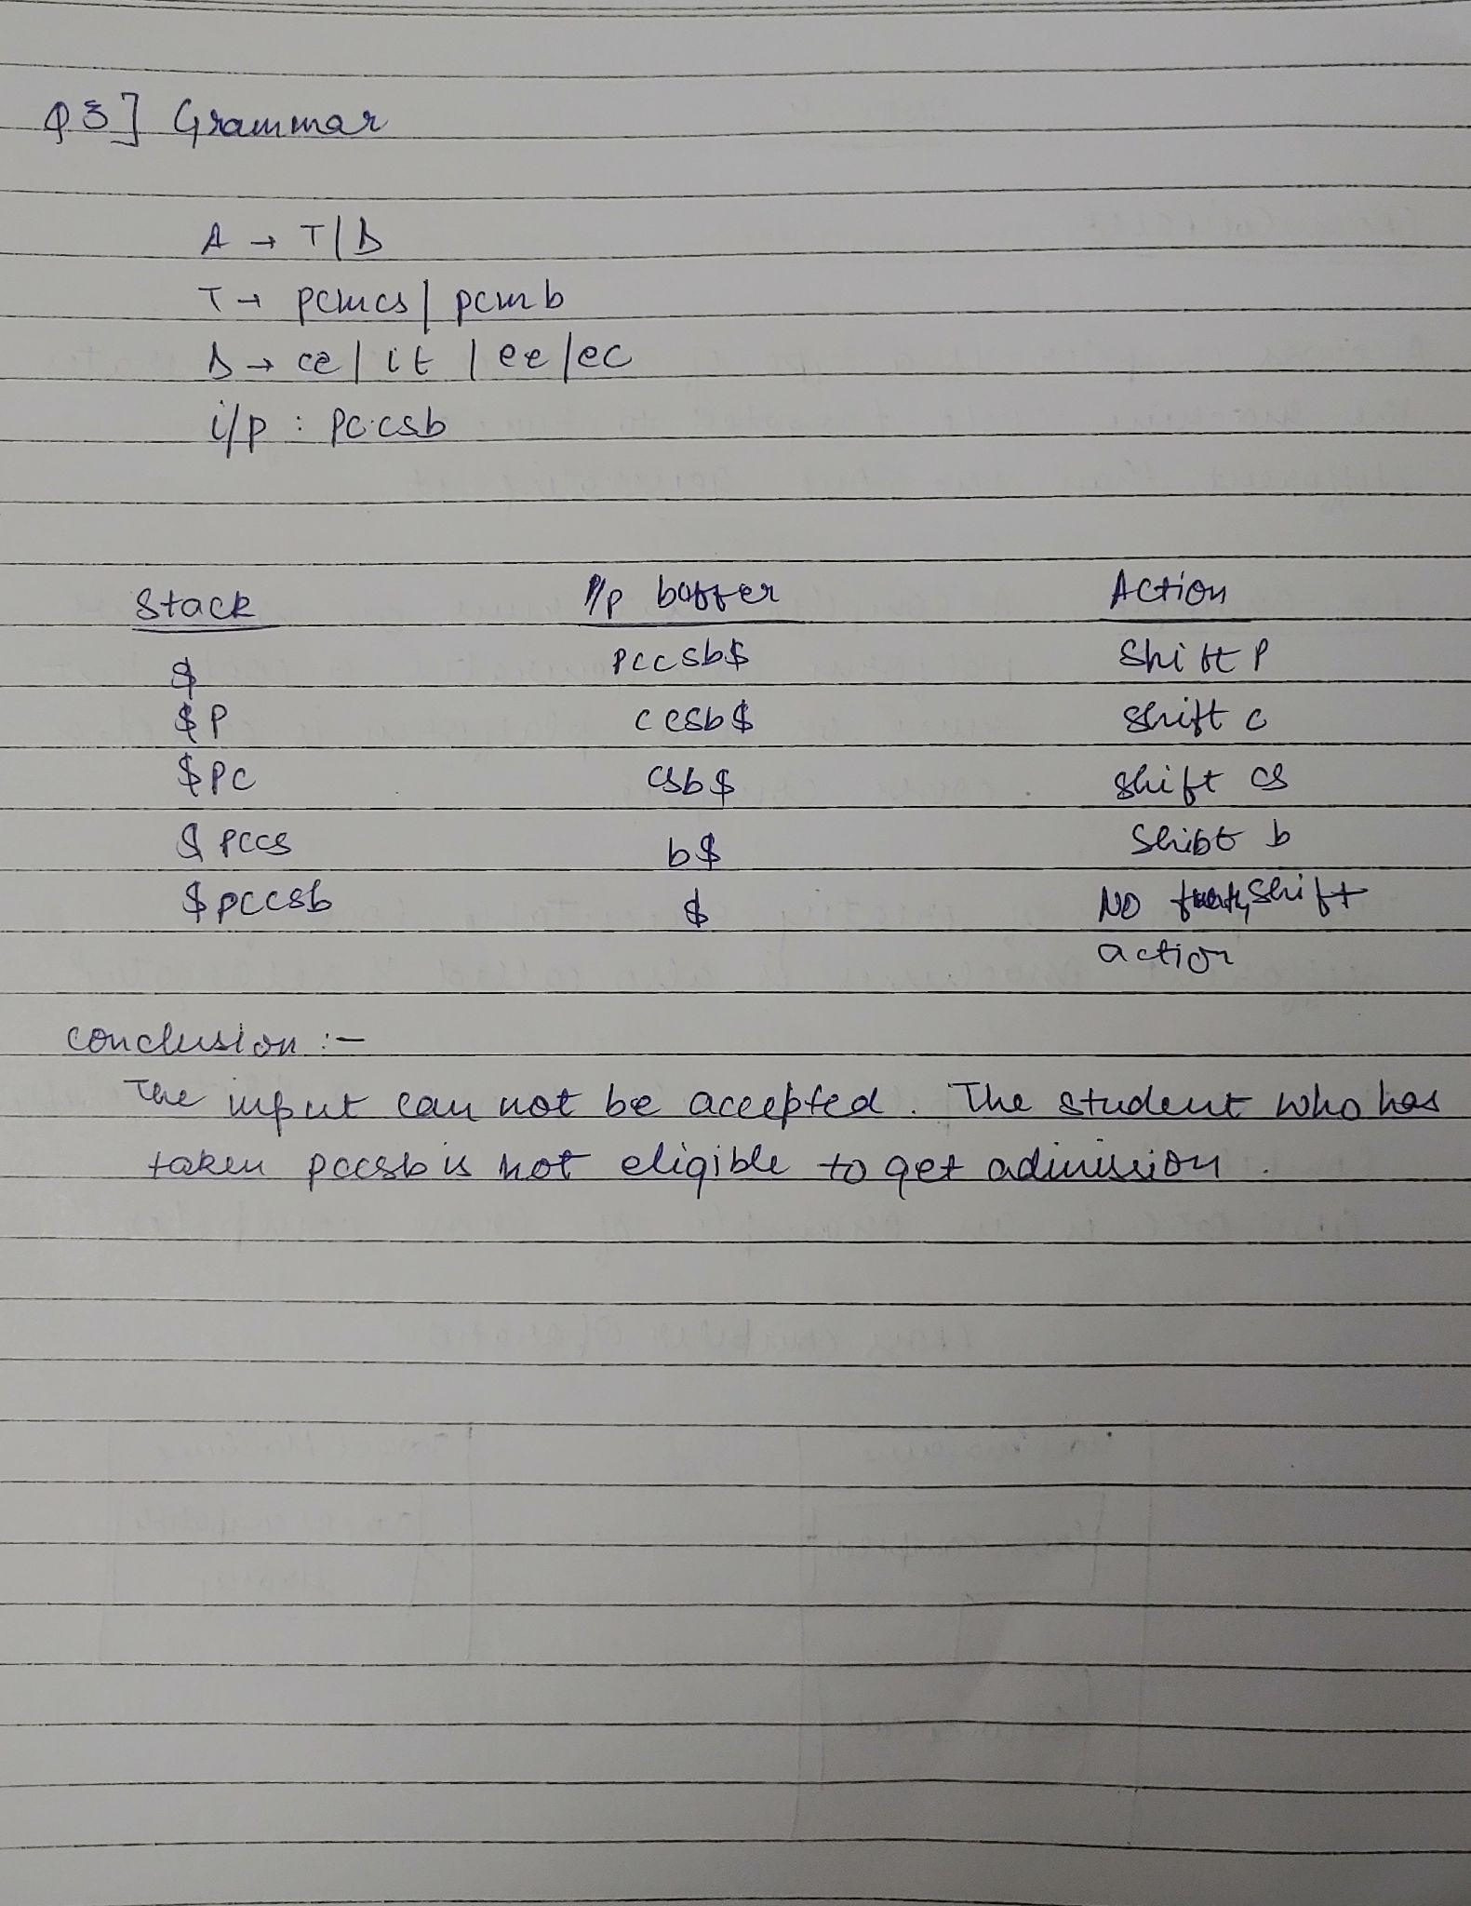

**UNIT 4**

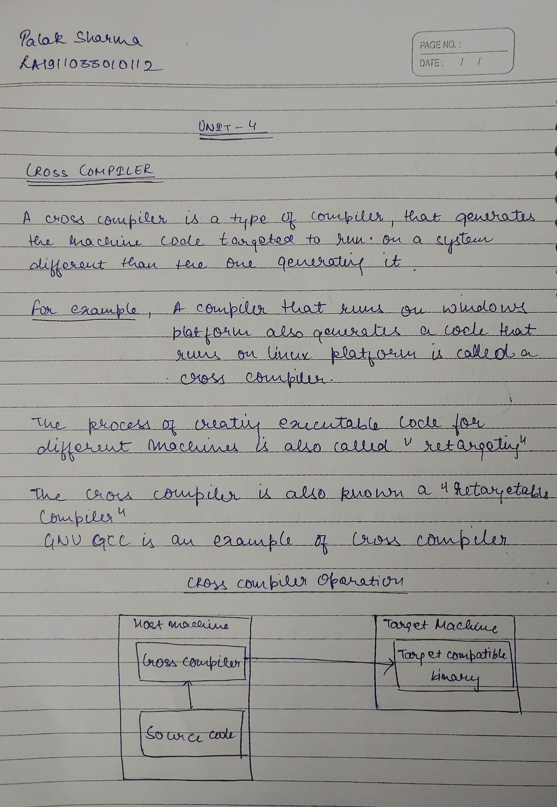

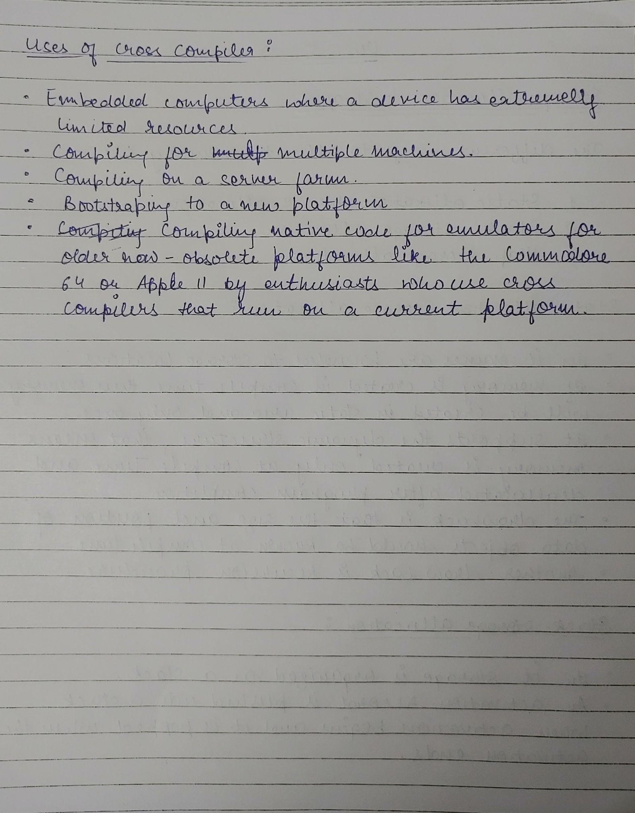

**UNIT 5**

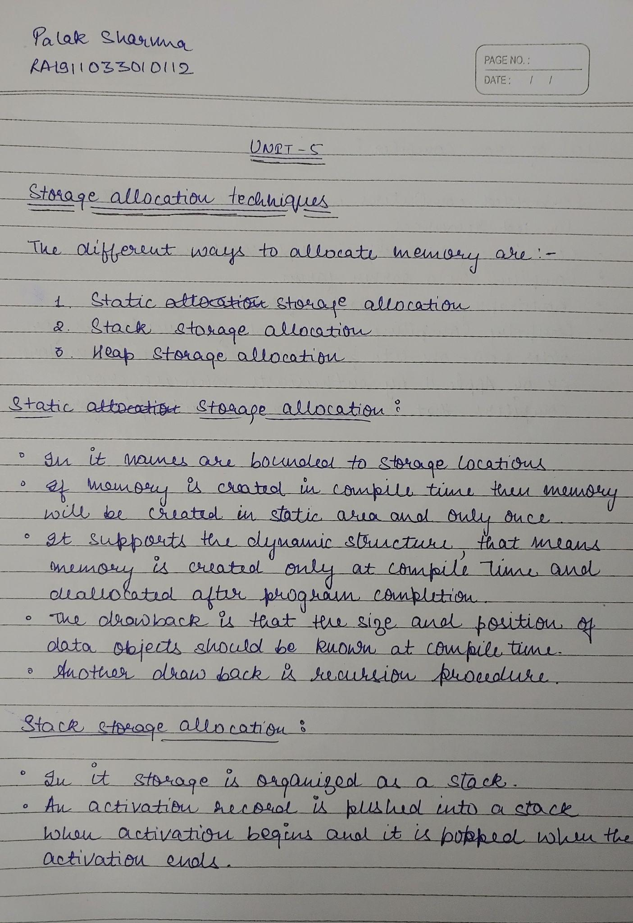

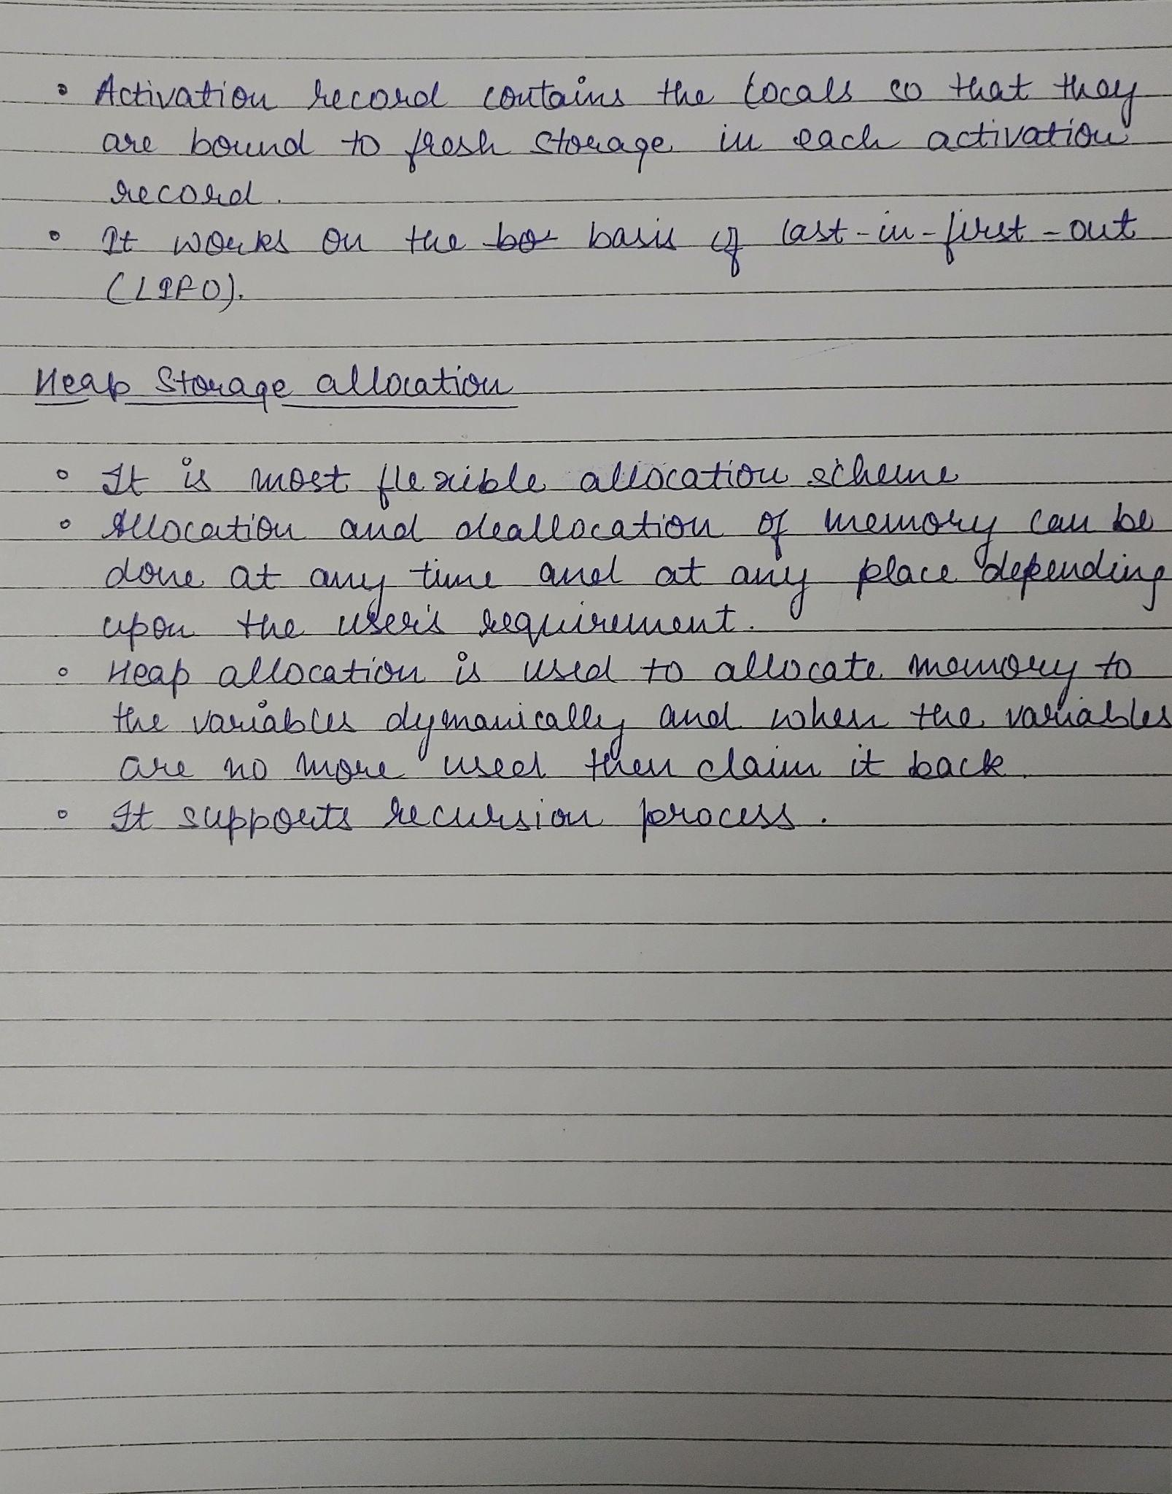

**HackerRank Regex Problems**

**1)**

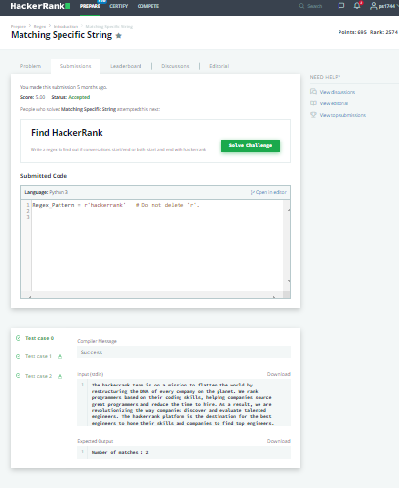

**2)**

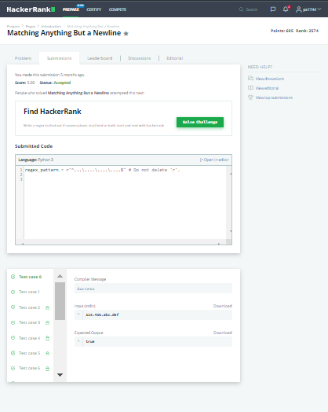

**3)**

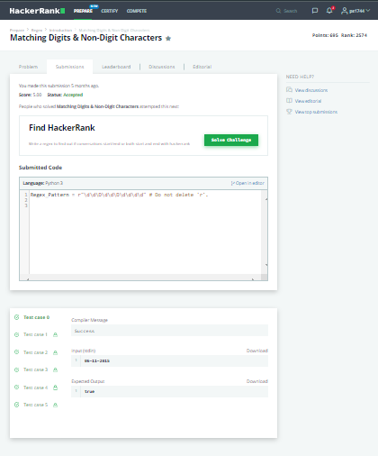

**4)**

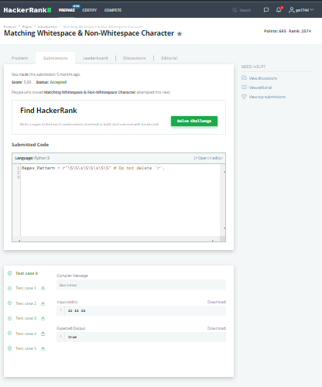

**5)**

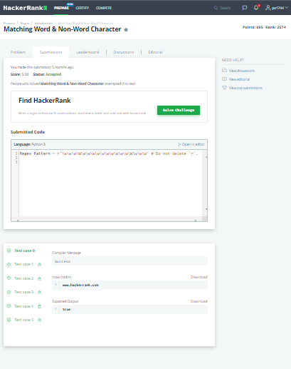

**6)**

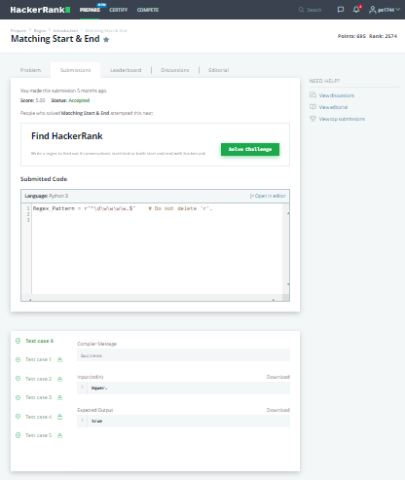

**7)**

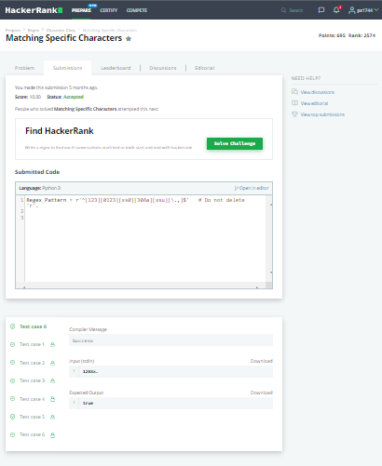

**8)**

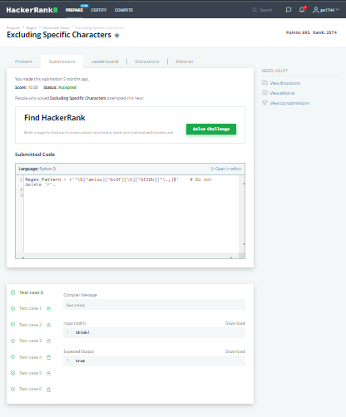

**9)**

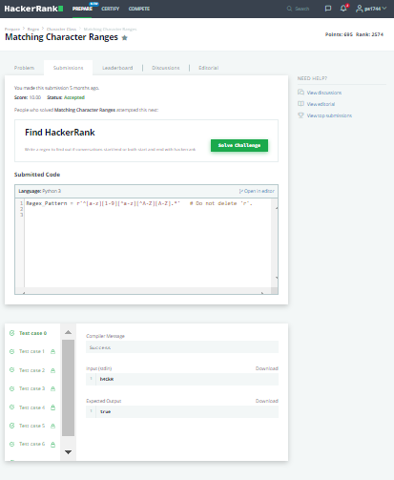

**10)**

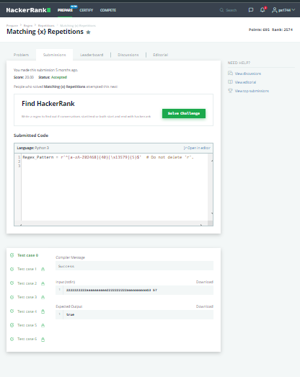

**11)**

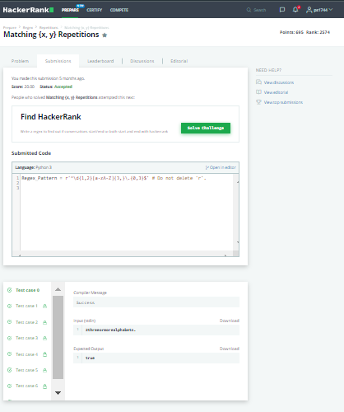

**12)**

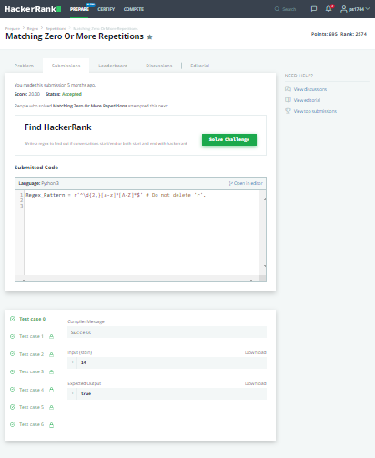

**13)**

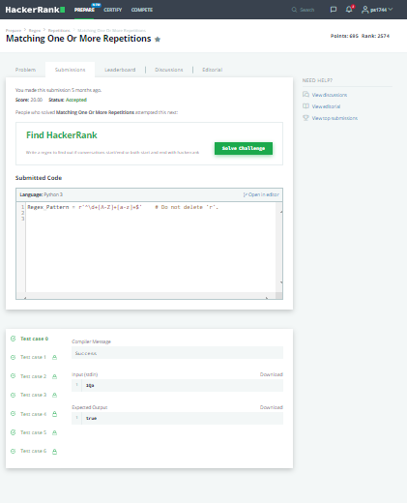

**14)**

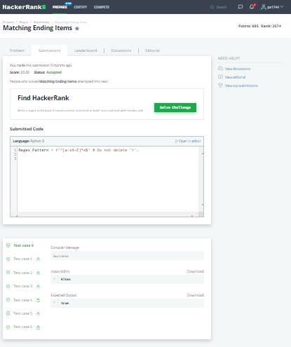

**15)**

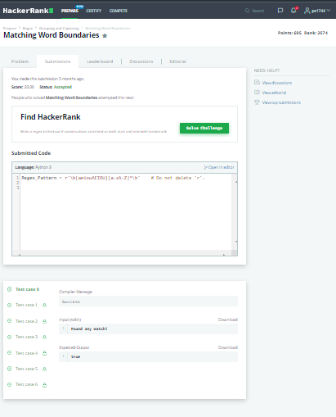

**16)**

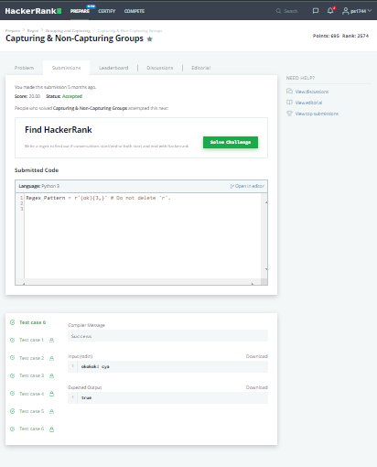

**17)**

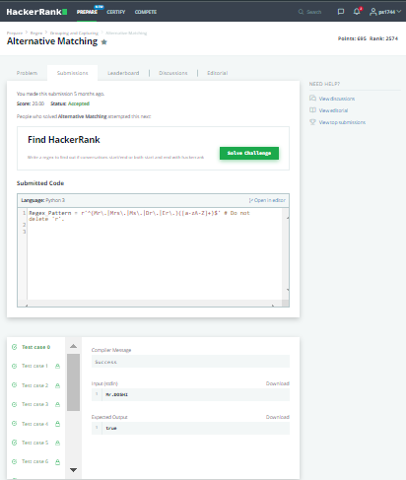

**18)**

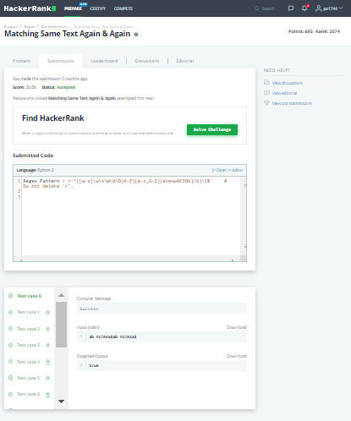

**19)**

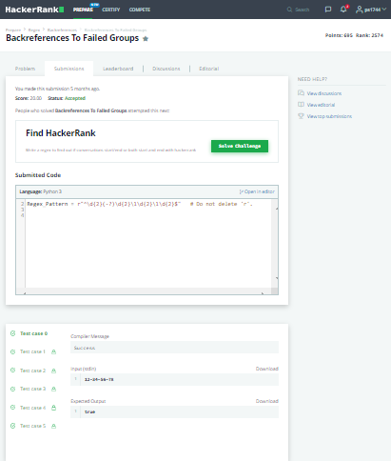

**20)**

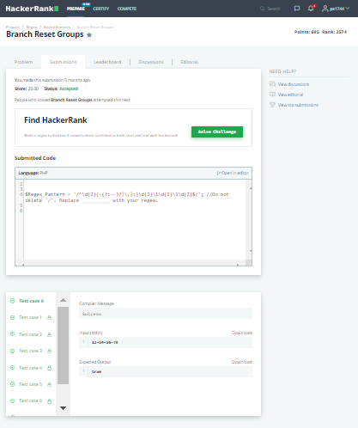

**21)**

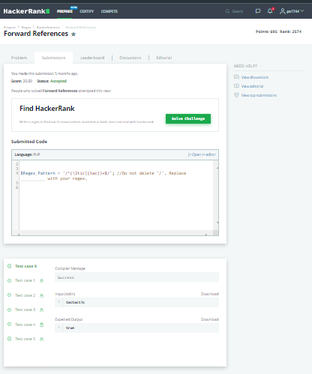

**22)**

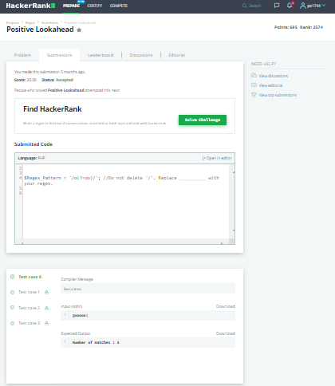

**23)**

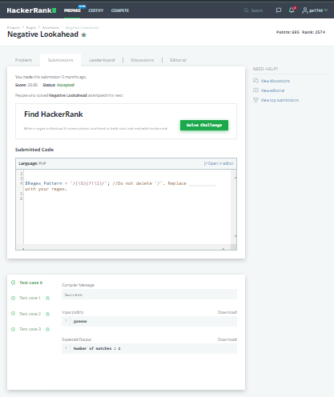

**24)**

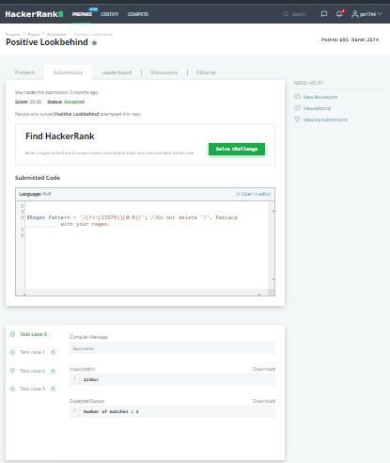

**25)**

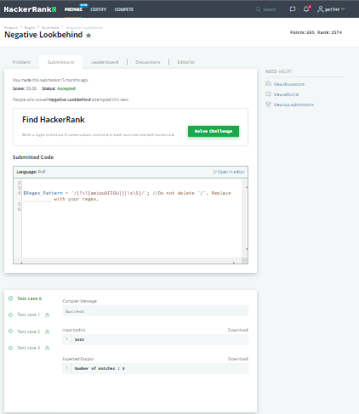

**26)**

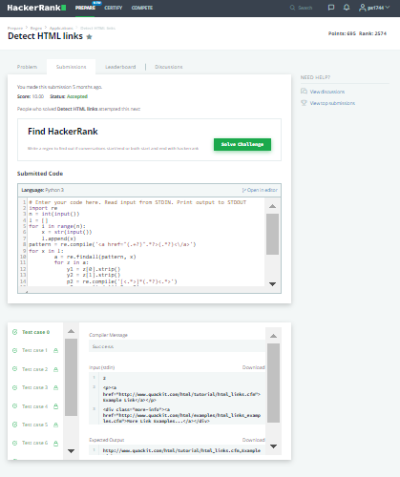

**27)**



**28)**

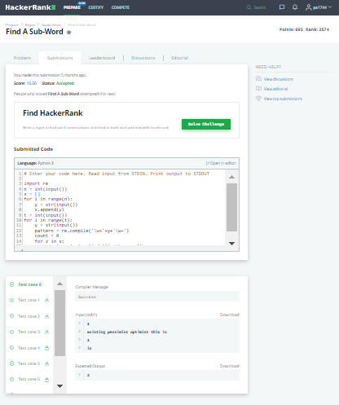

**29)**

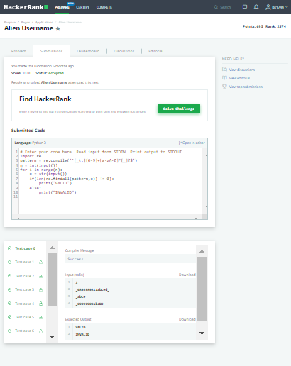

**30)**

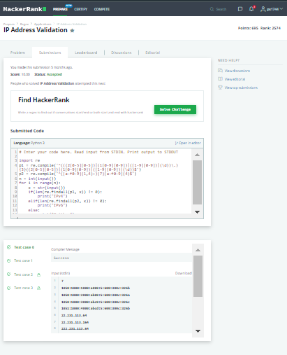

**31)**

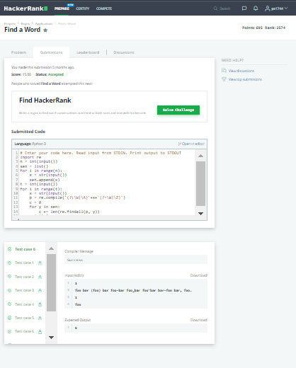

**32)**

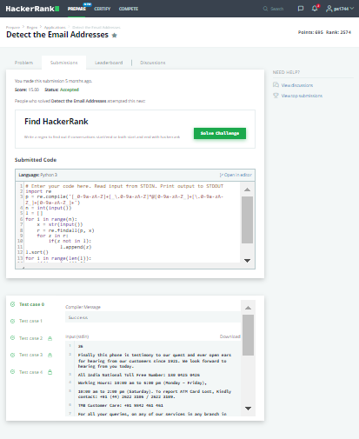

**33)**

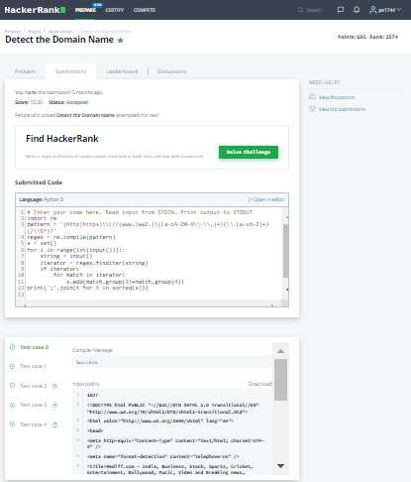

**34)**

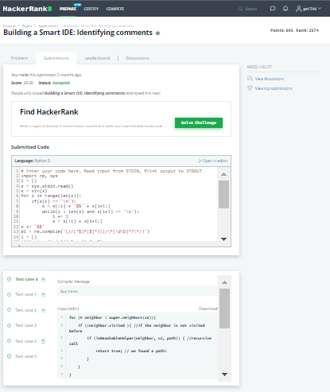

**35)**

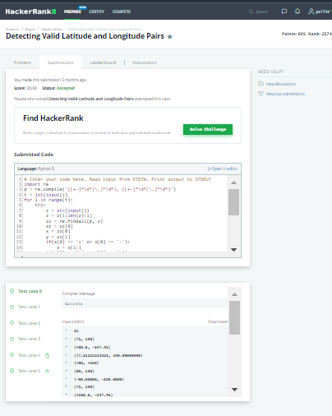

**36)**

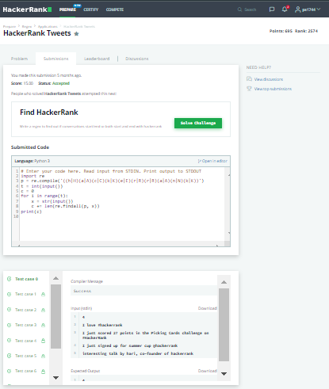

**37)**

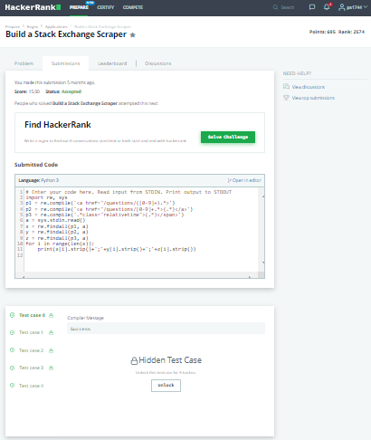

**38)**

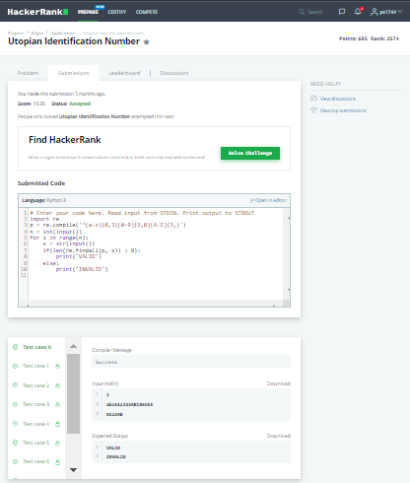

**39)**

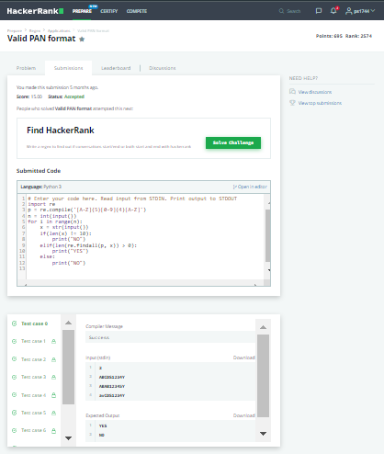

**40)**

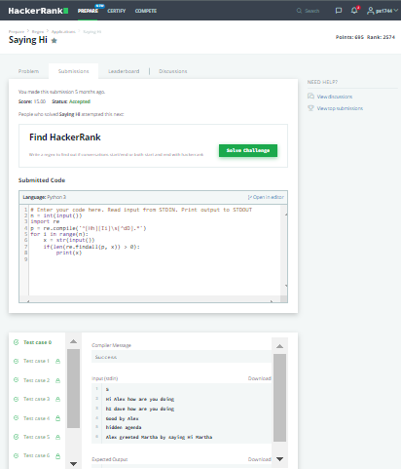

**41)**

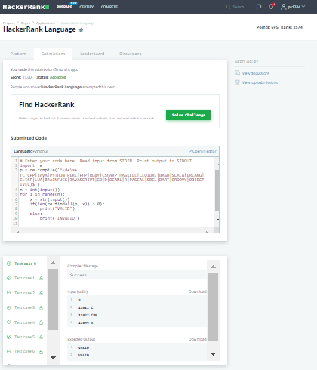

**42)**

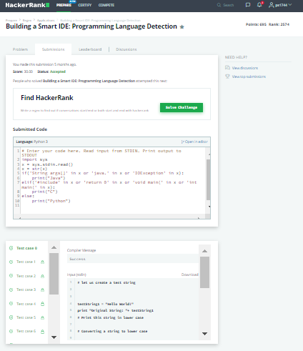

**43)**

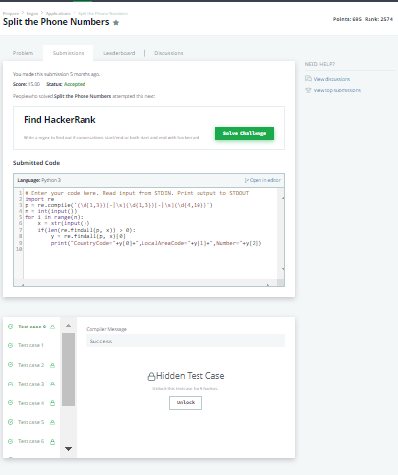

**44)**

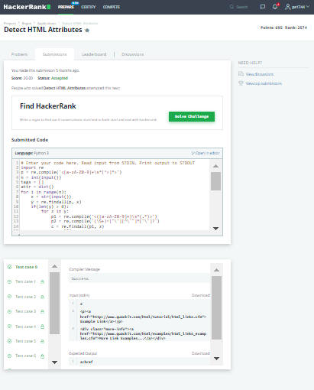

**45)**

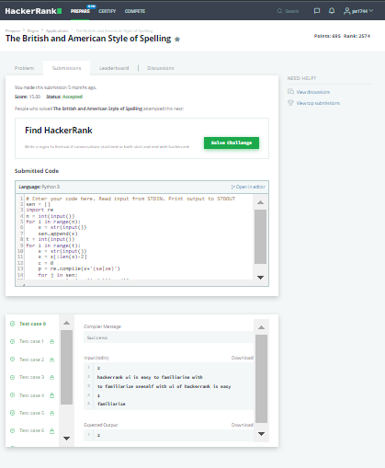

**46)**

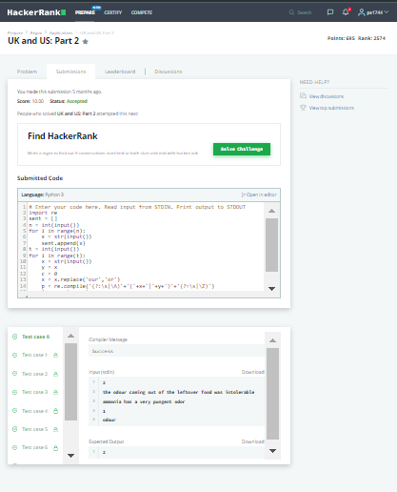

**LAB EXPERIMENTS**

**Palak Sharma**

**RA1911033010112**

**Expt. No. 1**

**Implementation of Lexical Analyser**

**AIM :**

Write a program in your preferred language for the Implementation of Lexical Analyser

**ALGORITHM :**

1. Start.
2. Get the input program from the file prog.txt.
3. Read the program line by line and check if each word in a line is a keyword, identifier, constant or an operator.
4. If the word read is an identifier, assign a number to the identifier and make an entry into the symbol table stored in sybol.txt.
5. For each lexeme read, generate a token as follows: a. If the lexeme is an identifier, then the token generated is of the form b. If the lexeme is an operator, then the token generated is . c. If the lexeme is a constant, then the token generated is . d. If the lexeme is a keyword, then the token is the keyword itself.
6. The stream of tokens generated are displayed in the console output.
7. Stop.

**CODE :**

file = open("./add.c", 'r')

lines = file.readlines()

keywords = ["void", "main", "int", "float", "bool", "if", "for", "else", "while", "char", "return"]

operators = ["=", "==", "+", "-", "*", "/", "++", "--", "+=", "-=", "!=", "||", "&&"]

punctuations= [";", "(", ")", "{", "}", "[", "]"]

def is_int(x):

try:

int(x)

return True

except:

return False

for line in lines:

for i in line.strip().split(" "):

if i in keywords:

print (i, " is a keyword")

elif i in operators:

print (i, " is an operator")

elif i in punctuations:

print (i, " is a punctuation")

elif is_int(i):

print (i, " is a number")

else:

print (i, " is an identifier")

**OUTPUT :**

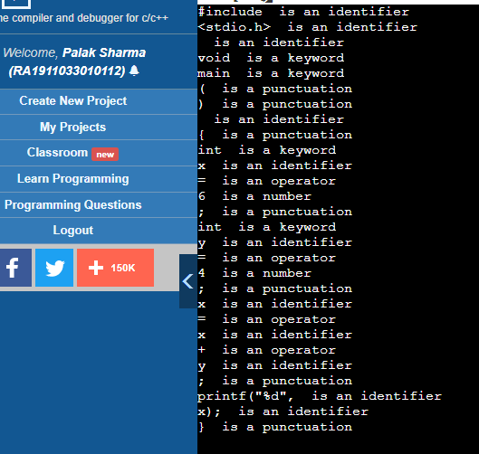

**RESULT :**  Implementation of Lexical Analyser is done in python.

**Palak Sharma**

**RA1911033010112**

**Expt. No. 2**

**Regular expression to NFA**

**AIM :**

To write a program in any language to convert a Regular Expression (RE) to a Non-Deterministic Finite Automata (NFA).

**ALGORITHM :**

1.Create the mandatory classes and accept the expression from the user.

2.After taking the RE as input convert it to postfix. This is done so as to know what the operator is to be used with how many variables.

3.A tree will be constructed after converting to postfix depending on the operators and the variables. A* will have a node where one of the next state values will be itself. A|B will have a state, branching into 2 new states.

4.Then we’ll evaluate the regular expression. Going from state to state, keeping a record of all the next states.

5. Finally, once all the nodes are traversed, print the list of states and the transition table.

**CODE :**

class Type:

SYMBOL = 1

CONCAT = 2

UNION = 3

KLEENE = 4

class ExpressionTree:

def __init__(self, _type, value=None):

self._type = _type

self.value = value

self.left = None

self.right = None

def constructTree(regexp):

stack = []

for c in regexp:

if c.isalpha():

stack.append(ExpressionTree(Type.SYMBOL, c))

else:

if c == "|":

z = ExpressionTree(Type.UNION)

z.right = stack.pop()

z.left = stack.pop()

elif c == ".":

z = ExpressionTree(Type.CONCAT)

z.right = stack.pop()

z.left = stack.pop()

elif c == "*":

z = ExpressionTree(Type.KLEENE)

z.left = stack.pop()

stack.append(z)

return stack[0]

def higherPrecedence(a, b):

p = ["|", ".", "*"]

return p.index(a) > p.index(b)

def postfix(regexp):

temp = []

for i in range(len(regexp)):

if i != 0 and (regexp[i-1].isalpha() or regexp[i-1] == ")" or regexp[i-1] == "*") and (regexp[i].isalpha() or regexp[i] == "("):

temp.append(".")

temp.append(regexp[i])

regexp = temp

stack = []

output = ""

for c in regexp:

if c.isalpha():

output = output + c

continue

if c == ")":

while len(stack) != 0 and stack[-1] != "(":

output = output + stack.pop()

stack.pop()

elif c == "(":

stack.append(c)

elif c == "*":

output = output + c

elif len(stack) == 0 or stack[-1] == "(" or higherPrecedence(c, stack[-1]):

stack.append(c)

else:

while len(stack) != 0 and stack[-1] != "(" and not higherPrecedence(c, stack[-1]):

output = output + stack.pop()

stack.append(c)

while len(stack) != 0:

output = output + stack.pop()

return output

class FiniteAutomataState:

def __init__(self):

self.next_state = {}

def evalRegex(et):

if et._type == Type.SYMBOL:

return evalRegexSymbol(et)

elif et._type == Type.CONCAT:

return evalRegexConcat(et)

elif et._type == Type.UNION:

return evalRegexUnion(et)

elif et._type == Type.KLEENE:

return evalRegexKleene(et)

def evalRegexSymbol(et):

start_state = FiniteAutomataState()

end_state = FiniteAutomataState()

start_state.next_state[et.value] = [end_state]

return start_state, end_state

def evalRegexConcat(et):

left_nfa = evalRegex(et.left)

right_nfa = evalRegex(et.right)

left_nfa[1].next_state['epsilon'] = [right_nfa[0]]

return left_nfa[0], right_nfa[1]

def evalRegexUnion(et):

start_state = FiniteAutomataState()

end_state = FiniteAutomataState()

up_nfa = evalRegex(et.left)

down_nfa = evalRegex(et.right)

start_state.next_state['epsilon'] = [up_nfa[0], down_nfa[0]]

up_nfa[1].next_state['epsilon'] = [end_state]

down_nfa[1].next_state['epsilon'] = [end_state]

return start_state, end_state

def evalRegexKleene(et):

start_state = FiniteAutomataState()

end_state = FiniteAutomataState()

sub_nfa = evalRegex(et.left)

start_state.next_state['epsilon'] = [sub_nfa[0], end_state]

sub_nfa[1].next_state['epsilon'] = [sub_nfa[0], end_state]

return start_state, end_state

def printStateTransitions(state, states_done, symbol_table):

if state in states_done:

return

states_done.append(state)

for symbol in list(state.next_state):

line_output = "q" + str(symbol_table[state]) + "\t\t" + symbol + "\t\t\t"

for ns in state.next_state[symbol]:

if ns not in symbol_table:

symbol_table[ns] = 1 + sorted(symbol_table.values())[-1]

line_output = line_output + "q" + str(symbol_table[ns]) + " "

print(line_output)

for ns in state.next_state[symbol]:

printStateTransitions(ns, states_done, symbol_table)

def printTransitionTable(finite_automata):

print("State\t\tSymbol\t\t\tNext state")

printStateTransitions(finite_automata[0], [], {finite_automata[0]: 0})

r = input("Enter regex: ")

pr = postfix(r)

et = constructTree(pr)

fa = evalRegex(et)

printTransitionTable(fa)

**OUTPUT :**

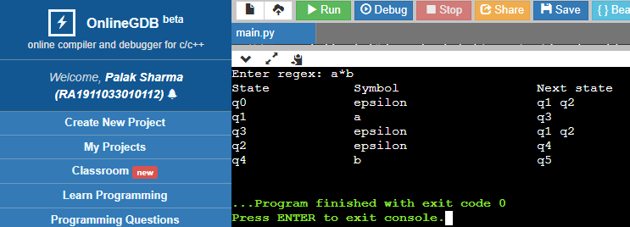

To verify the output here is a hand drawn conversion.

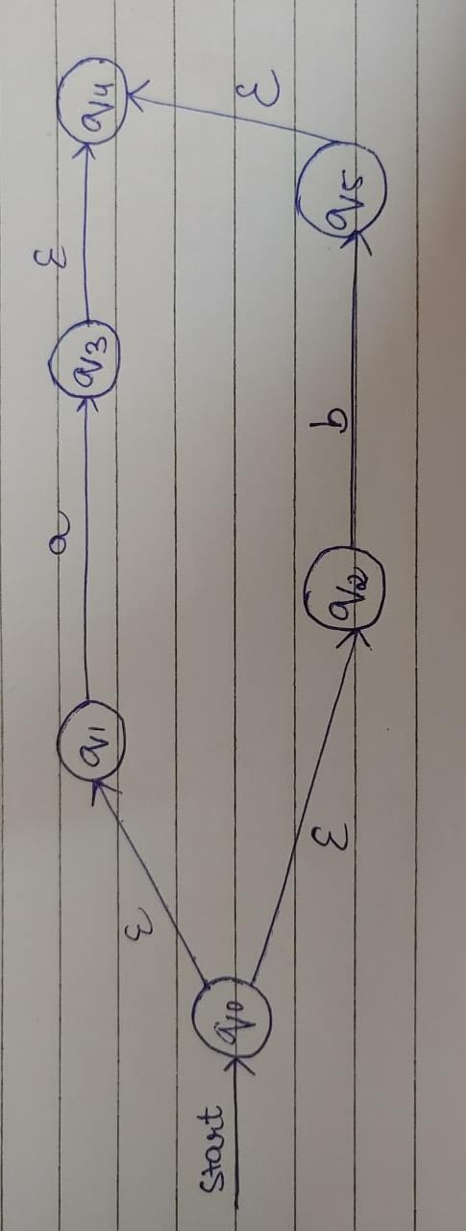

**RESULT :** Conversion of a Regular Expression (RE) to a Non-Deterministic Finite Automata (NFA).

**Palak Sharma**

**RA1911033010112**

# EX. NO. 3

# CONVERSION OF NFA TO DFA

**AIM :**

To write a program for converting NFA to DFA.

# ALGORITHM :

1. Start
2. Get the input from the user
3. Set the only state in SDFA to “unmarked”.
4. while SDFA contains an unmarked state do:
   1. Let T be that unmarked state
   2. for each a in % do S = e-Closure(MoveNFA(T,a))
   3. if S is not in SDFA already then, add S to SDFA (as an “unmarked” state)
   4. Set MoveDFA(T,a) to S
5. For each S in SDFA if any s & S is a final state in the NFA then, mark S an a final state in the DFA
6. Print the result.
7. Stop the program

# CODE :

import pandas as pd

nfa = {}

n = int(input("No. of states : "))

t = int(input("No. of transitions : "))

for i in range(n):

state = input("state name : ")

nfa[state] = {}

for j in range(t):

path = input("path : ")

print("Enter end state from state {} travelling through path {} : ".format(state, path))

reaching_state = [x for x in input().split()]

nfa[state][path] = reaching_state

print("\nNFA :- \n")

print(nfa)

print("\nPrinting NFA table :- ")

nfa_table = pd.DataFrame(nfa)

print(nfa_table.transpose())

print("Enter final state of NFA : ")

nfa_final_state = [x for x in input().split()]

new_states_list = []

#-------------------------------------------------

dfa = {}

keys_list = list(

list(nfa.keys())[0])

path_list = list(nfa[keys_list[0]].keys())

dfa[keys_list[0]] = {}

for y in range(t):

var = "".join(nfa[keys_list[0]][

path_list[y]])

dfa[keys_list[0]][path_list[y]] = var

if var not in keys_list:

new_states_list.append(var)

keys_list.append(var)

while len(new_states_list) != 0:

dfa[new_states_list[0]] = {}

for _ in range(len(new_states_list[0])):

for i in range(len(path_list)):

temp = []

for j in range(len(new_states_list[0])):

temp += nfa[new_states_list[0][j]][path_list[i]]

s = ""

s = s.join(temp)

if s not in keys_list:

new_states_list.append(s)

keys_list.append(s)

dfa[new_states_list[0]][path_list[i]] = s

new_states_list.remove(new_states_list[0])

print("\nDFA :- \n")

print(dfa)

print("\nPrinting DFA table :- ")

dfa_table = pd.DataFrame(dfa)

print(dfa_table.transpose())

dfa_states_list = list(dfa.keys())

dfa_final_states = []

for x in dfa_states_list:

for i in x:

if i in nfa_final_state:

dfa_final_states.append(x)

break

print("\nFinal states of the DFA are : ", dfa_final_states)

# OUTPUT :

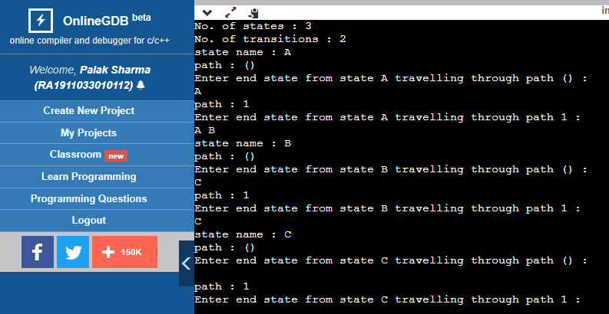

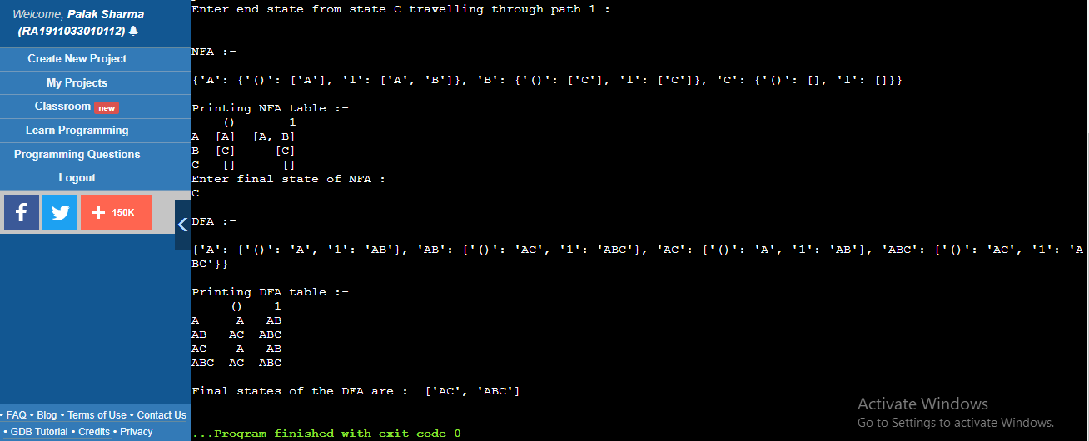

**RESULT :**

The given NFA was converted to a DFA using python successfully.

**Palak Sharma**

**RA1911033010112**

**EX. NO. 4(a)**

**ELIMINATION OF LEFT RECURSION**

**AIM :**

A program for Elimination of Left Recursion.

**ALGORITHM :**

1. Start the program.

2. Initialize the arrays for taking input from the user.

3. Prompt the user to input the no. of non-terminals having left recursion and no. of productions for these non-terminals.

4. Prompt the user to input the production for non-terminals.

5. Eliminate left recursion using the following rules:-

A->Aα1| Aα2 | . . . . . |Aαm

A->β1| β2| . . . . .| βn

Then replace it by

A-> βi A’ i=1,2,3,…..m

A’-> αj A’ j=1,2,3,…..n

A’-> Ɛ

6. After eliminating the left recursion by applying these rules, display the productions without left recursion.

7. Stop.

**CODE :**

#include <iostream>

#include <vector>

#include <string>

using namespace std;

int main()

{

int n;

cout<<"\nEnter number of non terminals: ";

cin>>n;

cout<<"\nEnter non terminals one by one: ";

int i;

vector<string> nonter(n);

vector<int> leftrecr(n,0);

for(i=0;i<n;++i) {

cout<<"\nNon terminal "<<i+1<<" : ";

cin>>nonter[i];

}

vector<vector<string> > prod;

cout<<"\nEnter 'esp' for null";

for(i=0;i<n;++i) {

cout<<"\nNumber of "<<nonter[i]<<" productions: ";

int k;

cin>>k;

int j;

cout<<"\nOne by one enter all "<<nonter[i]<<" productions";

vector<string> temp(k);

for(j=0;j<k;++j) {

cout<<"\nRHS of production "<<j+1<<": ";

string abc;

cin>>abc;

temp[j]=abc;

if(nonter[i].length()<=abc.length()&&nonter[i].compare(abc.substr(0,nonter[i].length()))==0)

leftrecr[i]=1;

}

prod.push_back(temp);

}

for(i=0;i<n;++i) {

cout<<leftrecr[i];

}

for(i=0;i<n;++i) {

if(leftrecr[i]==0)

continue;

int j;

nonter.push_back(nonter[i]+"'");

vector<string> temp;

for(j=0;j<prod[i].size();++j) {

if(nonter[i].length()<=prod[i][j].length()&&nonter[i].compare(prod[i][j].substr(0,nonter[i].length()))==0) {

string abc=prod[i][j].substr(nonter[i].length(),prod[i][j].length()-nonter[i].length())+nonter[i]+"'";

temp.push_back(abc);

prod[i].erase(prod[i].begin()+j);

--j;

}

else {

prod[i][j]+=nonter[i]+"'";

}

}

temp.push_back("esp");

prod.push_back(temp);

}

cout<<"\n\n";

cout<<"\nNew set of non-terminals: ";

for(i=0;i<nonter.size();++i)

cout<<nonter[i]<<" ";

cout<<"\n\nNew set of productions: ";

for(i=0;i<nonter.size();++i) {

int j;

for(j=0;j<prod[i].size();++j) {

cout<<"\n"<<nonter[i]<<" -> "<<prod[i][j];

}

}

return 0;

}

**OUTPUT :**

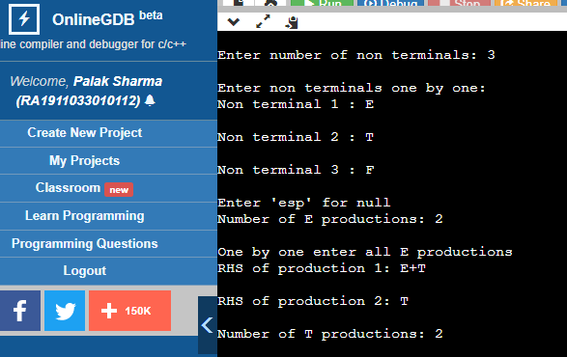

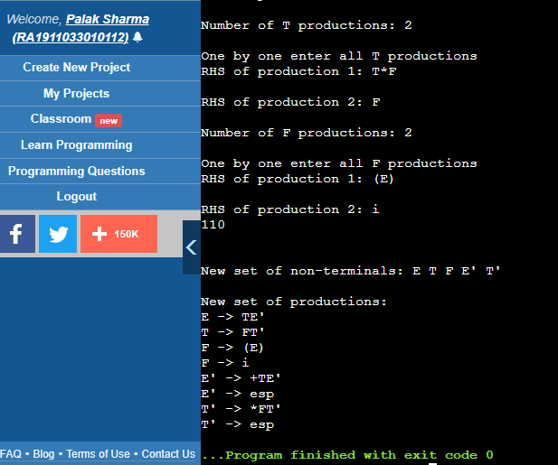

**RESULT :** A program for Elimination of Left Recursion was run successfully

**Palak Sharma**

**RA1911033010112**

**EX. NO. 4(b)**

**LEFT FACTORING**

**AIM :**

A program for implementation Of Left Factoring

**ALGORITHM :**

1. Start

2. Ask the user to enter the set of productions

3. Check for common symbols in the given set of productions by comparing with: A->aB1|aB2

4. If found, replace the particular productions with:

A->aA’

A’->B1 | B2|ɛ

5. Display the output

6. Exit

**CODE :**

#include<string.h>

#include<stdio.h>

#include<stdlib.h>

#include<conio.h>

void main()

{

char ch,lhs[20][20],rhs[20][20][20],temp[20],temp1[20];

int n,n1,count[20],x,y,i,j,k,c[20];

printf("\nEnter the no. of nonterminals : ");

scanf("%d",&n);

n1=n;

for(i=0;i<n;i++)

{

printf("\nNonterminal %d \nEnter the no. of productions : ",i+1);

scanf("%d",&c[i]);

printf("\nEnter LHS : ");

scanf("%s",lhs[i]);

for(j=0;j<c[i];j++)

{

printf("%s->",lhs[i]);

scanf("%s",rhs[i][j]);

}

}

for(i=0;i<n;i++)

{

count[i]=1;

while(memcmp(rhs[i][0],rhs[i][1],count[i])==0)

count[i]++;

}

for(i=0;i<n;i++)

{

count[i]--;

if(count[i]>0)

{

strcpy(lhs[n1],lhs[i]);

strcat(lhs[i],"'");

for(k=0;k<count[i];k++)

temp1[k] = rhs[i][0][k];

temp1[k++] = '\0';

for(j=0;j<c[i];j++)

{

for(k=count[i],x=0;k<strlen(rhs[i][j]);x++,k++)

temp[x] = rhs[i][j][k];

temp[x++] = '\0';

if(strlen(rhs[i][j])==1)

strcpy(rhs[n1][1],rhs[i][j]);

strcpy(rhs[i][j],temp);

}

c[n1]=2;

strcpy(rhs[n1][0],temp1);

strcat(rhs[n1][0],lhs[n1]);

strcat(rhs[n1][0],"'");

n1++;

}

}

printf("\n\nThe resulting productions are : \n");

for(i=0;i<n1;i++)

{

if(i==0)

printf("\n %s -> %c|",lhs[i],(char)238);

else

printf("\n %s -> ",lhs[i]);

for(j=0;j<c[i];j++)

{

printf(" %s ",rhs[i][j]);

if((j+1)!=c[i])

printf("|");

}

printf("\b\b\b\n");

}

}

**OUTPUT :**

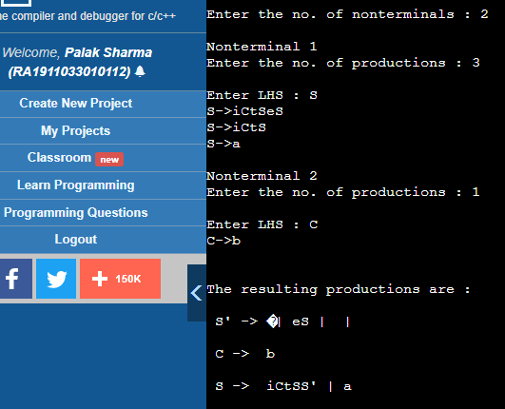

**RESULT :** A program for implementation Of Left Factoring was compiled and run successful

**Palak Sharma**

**RA1911033010112**

**Exp 5**

**Computation of First and Follow**

**AIM :**

To study and implement Computation of First and Follow.

**ALGORITHM :**

> If x is a terminal, then FIRST(x) = { ‘x’ }

> If x-> Є, is a production rule, then add Є to FIRST(x). ➢ If X->Y1 Y2 Y3….Yn is a production,

• FIRST(X) = FIRST(Y1)

• If FIRST(Y1) contains Є then FIRST(X) = { FIRST(Y1) – Є } U { FIRST(Y2) }

• If FIRST (Yi) contains Є for all i = 1 to n, then add Є to FIRST(X).

> Always check the right side of the productions for a non-terminal, whose FOLLOW set is being found. ( never see the left side ). ➢ Follow =>

• If that non-terminal (S,A,B…) is followed by any terminal (a,b…,*,+,(,)…) , then add that “terminal” into FOLLOW set. • If that non-terminal is followed by any other non-terminal then add “FIRST of other nonterminal” into FOLLOW set.

**CODE :**

// C program to calculate the First and

// Follow sets of a given grammar

#include<stdio.h>

#include<ctype.h>

#include<string.h>

// Functions to calculate Follow

void followfirst(char, int, int);

void follow(char c);

// Function to calculate First

void findfirst(char, int, int);

int count, n = 0;

// Stores the final result

// of the First Sets

char calc_first[10][100];

// Stores the final result

// of the Follow Sets

char calc_follow[10][100];

int m = 0;

// Stores the production rules

char production[10][10];

char f[10], first[10];

int k;

char ck;

int e;

int main(int argc, char **argv)

{

int jm = 0;

int km = 0;

int i, choice;

char c, ch;

count = 8;

// The Input grammar

strcpy(production[0], "E=TR");

strcpy(production[1], "R=+TR");

strcpy(production[2], "R=#");

strcpy(production[3], "T=FY");

strcpy(production[4], "Y=*FY");

strcpy(production[5], "Y=#");

strcpy(production[6], "F=(E)");

strcpy(production[7], "F=i");

int kay;

char done[count];

int ptr = -1;

// Initializing the calc_first array

for(k = 0; k < count; k++) {

for(kay = 0; kay < 100; kay++) {

calc_first[k][kay] = '!';

}

}

int point1 = 0, point2, xxx;

for(k = 0; k < count; k++)

{

c = production[k][0];

point2 = 0;

xxx = 0;

// Checking if First of c has

// already been calculated

for(kay = 0; kay <= ptr; kay++)

if(c == done[kay])

xxx = 1;

if (xxx == 1)

continue;

// Function call

findfirst(c, 0, 0);

ptr += 1;

// Adding c to the calculated list

done[ptr] = c;

printf("\n First(%c) = { ", c);

calc_first[point1][point2++] = c;

// Printing the First Sets of the grammar

for(i = 0 + jm; i < n; i++) {

int lark = 0, chk = 0;

for(lark = 0; lark < point2; lark++) {

if (first[i] == calc_first[point1][lark])

{

chk = 1;

break;

}

}

if(chk == 0)

{

printf("%c, ", first[i]);

calc_first[point1][point2++] = first[i];

}

}

printf("}\n");

jm = n;

point1++;

}

printf("\n");

printf("-----------------------------------------------\n\n");

char donee[count];

ptr = -1;

// Initializing the calc_follow array

for(k = 0; k < count; k++) {

for(kay = 0; kay < 100; kay++) {

calc_follow[k][kay] = '!';

}

}

point1 = 0;

int land = 0;

for(e = 0; e < count; e++)

{

ck = production[e][0];

point2 = 0;

xxx = 0;

// Checking if Follow of ck

// has alredy been calculated

for(kay = 0; kay <= ptr; kay++)

if(ck == donee[kay])

xxx = 1;

if (xxx == 1)

continue;

land += 1;

// Function call

follow(ck);

ptr += 1;

// Adding ck to the calculated list

donee[ptr] = ck;

printf(" Follow(%c) = { ", ck);

calc_follow[point1][point2++] = ck;

// Printing the Follow Sets of the grammar

for(i = 0 + km; i < m; i++) {

int lark = 0, chk = 0;

for(lark = 0; lark < point2; lark++)

{

if (f[i] == calc_follow[point1][lark])

{

chk = 1;

break;

}

}

if(chk == 0)

{

printf("%c, ", f[i]);

calc_follow[point1][point2++] = f[i];

}

}

printf(" }\n\n");

km = m;

point1++;

}

}

void follow(char c)

{

int i, j;

// Adding "$" to the follow

// set of the start symbol

if(production[0][0] == c) {

f[m++] = '$';

}

for(i = 0; i < 10; i++)

{

for(j = 2;j < 10; j++)

{

if(production[i][j] == c)

{

if(production[i][j+1] != '\0')

{

// Calculate the first of the next

// Non-Terminal in the production

followfirst(production[i][j+1], i, (j+2));

}

if(production[i][j+1]=='\0' && c!=production[i][0])

{

// Calculate the follow of the Non-Terminal

// in the L.H.S. of the production

follow(production[i][0]);

}

}

}

}

}

void findfirst(char c, int q1, int q2)

{

int j;

// The case where we

// encounter a Terminal

if(!(isupper(c))) {

first[n++] = c;

}

for(j = 0; j < count; j++)

{

if(production[j][0] == c)

{

if(production[j][2] == '#')

{

if(production[q1][q2] == '\0')

first[n++] = '#';

else if(production[q1][q2] != '\0'

&& (q1 != 0 || q2 != 0))

{

// Recursion to calculate First of New

// Non-Terminal we encounter after epsilon

findfirst(production[q1][q2], q1, (q2+1));

}

else

first[n++] = '#';

}

else if(!isupper(production[j][2]))

{

first[n++] = production[j][2];

}

else

{

// Recursion to calculate First of

// New Non-Terminal we encounter

// at the beginning

findfirst(production[j][2], j, 3);

}

}

}

}

void followfirst(char c, int c1, int c2)

{

int k;

// The case where we encounter

// a Terminal

if(!(isupper(c)))

f[m++] = c;

else

{

int i = 0, j = 1;

for(i = 0; i < count; i++)

{

if(calc_first[i][0] == c)

break;

}

//Including the First set of the

// Non-Terminal in the Follow of

// the original query

while(calc_first[i][j] != '!')

{

if(calc_first[i][j] != '#')

{

f[m++] = calc_first[i][j];

}

else

{

if(production[c1][c2] == '\0')

{

// Case where we reach the

// end of a production

follow(production[c1][0]);

}

else

{

// Recursion to the next symbol

// in case we encounter a "#"

followfirst(production[c1][c2], c1, c2+1);

}

}

j++;

}

}

}

**OUTPUT :**

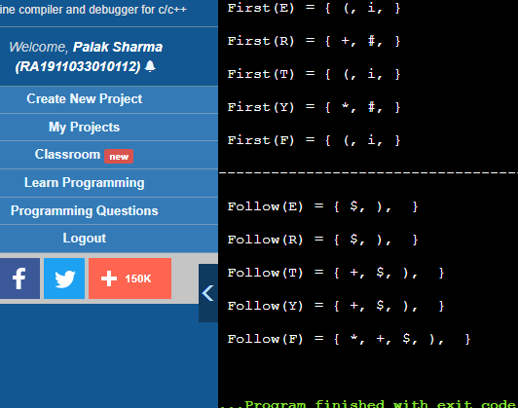

**RESULT :**

The code was successfully implemented using c++ and output was recorded.

**Palak Sharma**

**RA1911033010112**

**EXPERIMENT 6**

**PREDICTIVE PARSING**

**AIM :**

A program for Predictive Parsing

**ALGORITHM :**

1. Start the program.

2. Initialize the required variables.

3. Get the number of coordinates and productions from the user. 4. Perform the following

for (each production A → α in G) {

for (each terminal a in FIRST(α))

add A → α to M[A, a];

if (ε is in FIRST(α))

for (each symbol b in FOLLOW(A))

add A → α to M[A, b];

5. Print the resulting stack.

6. Print if the grammar is accepted or not.

7. Exit the program.

**CODE :**

#include<stdio.h>

#include<conio.h>

#include<string.h>

void main()

{

char fin[10][20],st[10][20],ft[20][20],fol[20][20];

int a=0,e,i,t,b,c,n,k,l=0,j,s,m,p;

printf("enter the no. of nonterminals\n");

scanf("%d",&n);

printf("enter the productions in a grammar\n");

for(i=0;i<n;i++)

scanf("%s",st[i]);

for(i=0;i<n;i++)

fol[i][0]='\0';

for(s=0;s<n;s++)

{

for(i=0;i<n;i++)

{

j=3;

l=0;

a=0;

l1:if(!((st[i][j]>64)&&(st[i][j]<91)))

{

for(m=0;m<l;m++)

{

if(ft[i][m]==st[i][j])

goto s1;

}

ft[i][l]=st[i][j];

l=l+1;

s1:j=j+1;

}

else

{

if(s>0)

{

while(st[i][j]!=st[a][0])

{

a++;

}

b=0;

while(ft[a][b]!='\0')

{

for(m=0;m<l;m++)

{

if(ft[i][m]==ft[a][b])

goto s2;

}

ft[i][l]=ft[a][b];

l=l+1;

s2:b=b+1;

}

}

}

while(st[i][j]!='\0')

{

if(st[i][j]=='|')

{

j=j+1;

goto l1;

}

j=j+1;

}

ft[i][l]='\0';

}

}

printf("first \n");

for(i=0;i<n;i++)

printf("FIRS[%c]=%s\n",st[i][0],ft[i]);

fol[0][0]='$';

for(i=0;i<n;i++)

{

k=0;

j=3;

if(i==0)

l=1;

else

l=0;

k1:while((st[i][0]!=st[k][j])&&(k<n))

{

if(st[k][j]=='\0')

{

k++;

j=2;

}

j++;

}

j=j+1;

if(st[i][0]==st[k][j-1])

{

if((st[k][j]!='|')&&(st[k][j]!='\0'))

{

a=0;

if(!((st[k][j]>64)&&(st[k][j]<91)))

{

for(m=0;m<l;m++)

{

if(fol[i][m]==st[k][j])

goto q3;

}

fol[i][l]=st[k][j];

l++;

q3:;

}

else

{

while(st[k][j]!=st[a][0])

{

a++;

}

p=0;

while(ft[a][p]!='\0')

{

if(ft[a][p]!='@')

{

for(m=0;m<l;m++)

{

if(fol[i][m]==ft[a][p])

goto q2;

}

fol[i][l]=ft[a][p];

l=l+1;

}

else

e=1;

q2:p++;

}

if(e==1)

{

e=0;

goto a1;

}

}

}

else

{

a1:c=0;

a=0;

while(st[k][0]!=st[a][0])

{

a++;

}

while((fol[a][c]!='\0')&&(st[a][0]!=st[i][0]))

{

for(m=0;m<l;m++)

{

if(fol[i][m]==fol[a][c])

goto q1;

}

fol[i][l]=fol[a][c];

l++;

q1:c++;

}

}

goto k1;

}

fol[i][l]='\0';

}

printf("follow \n");

for(i=0;i<n;i++)

printf("FOLLOW[%c]=%s\n",st[i][0],fol[i]);

printf("\n");

s=0;

for(i=0;i<n;i++)

{

j=3;

while(st[i][j]!='\0')

{

if((st[i][j-1]=='|')||(j==3))

{

for(p=0;p<=2;p++)

{

fin[s][p]=st[i][p];

}

t=j;

for(p=3;((st[i][j]!='|')&&(st[i][j]!='\0'));p++)

{

fin[s][p]=st[i][j];

j++;

}

fin[s][p]='\0';

if(st[i][k]=='@')

{

b=0;

a=0;

while(st[a][0]!=st[i][0])

{

a++;

}

while(fol[a][b]!='\0')

{

printf("M[%c,%c]=%s\n",st[i][0],fol[a][b],fin[s]);

b++;

}

}

else if(!((st[i][t]>64)&&(st[i][t]<91)))

printf("M[%c,%c]=%s\n",st[i][0],st[i][t],fin[s]);

else

{

b=0;

a=0;

while(st[a][0]!=st[i][3])

{

a++;

}

while(ft[a][b]!='\0')

{

printf("M[%c,%c]=%s\n",st[i][0],ft[a][b],fin[s]);

b++;

}

}

s++;

}

if(st[i][j]=='|')

j++;

}

}

}

**OUTPUT :**

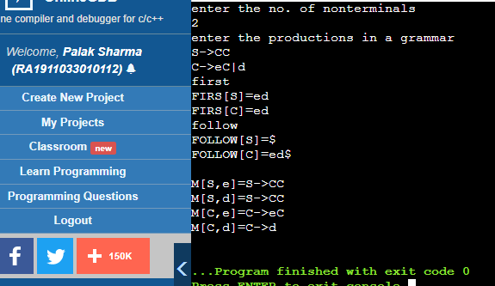

**RESULT :** The program was successfully compiled and run.

# 

**Palak Sharma**

**RA1911033010112**

**Exp 7**

**SHIFT REDUCE PARSING**

**AIM :**

To perform shift reduce parsing for the given input string.

**ALGORITHM :**

1. Start

2. First we take the number of production rules as well the production rules as an input form the user. We also sanitize the input from spaces.

3. For a given production rule =>

a. We split the lexemes on the left and the right side of the “->” symbol. The left side contains a non-terminal.

b. We again split the right side lexemes on basis of ‘|’

character and store it in list.

c. We store the list in a dictionary with right side (non

terminal) as the key.

4. We also take the input string to test from the user and append ‘$’ to it.

5. Set up a stack having initial symbol ‘$’ and set up an input cursor to 0 pointing to the first character of the input.

6. We compare the top of stack with the production rules. If a found is match we reduce the elements in the stack to the

corresponding non-terminal of the production rule. This is the reduce operation.

7. If no match we perform shift operation by removing a character pointed out by the input cursor and push it into the stack.

8. If operation 6 and 7 cannot be carried out we display string is rejected in the output.

9. We repeat from step 6 again until the input cursor reaches the end of the input string (i.e, upto the ‘$’ symbol in test) and there are only 1 element in stack including the ‘$’ symbol.

10. Print string is accepted.

11. Stop.

**CODE :**

gram = {

"E":["E*E","E+E","i"]

}

starting_terminal = "E"

inp = "i+i*i"

stack = "$"

print(f'{"Stack": <15}'+"|"+f'{"Input Buffer": <15}'+"|"+f'Parsing Action')

print(f'{"-":-<50}')

while True:

action = True

i = 0

while i<len(gram[starting_terminal]):

if gram[starting_terminal][i] in stack:

stack = stack.replace(gram[starting_terminal][i],starting_terminal)

print(f'{stack: <15}'+"|"+f'{inp: <15}'+"|"+f'Reduce S->{gram[starting_terminal][i]}')

i=-1

action = False

i+=1

if len(inp)>1:

stack+=inp[0]

inp=inp[1:]

print(f'{stack: <15}'+"|"+f'{inp: <15}'+"|"+f'Shift')

action = False

if inp == "$" and stack == ("$"+starting_terminal):

print(f'{stack: <15}'+"|"+f'{inp: <15}'+"|"+f'Accepted')

break

if action:

print(f'{stack: <15}'+"|"+f'{inp: <15}'+"|"+f'Rejected')

break

**OUTPUT :**

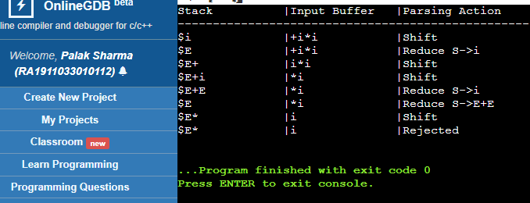

**RESULT :**

Implementation ofshift reduce parsing for the given input string is done.

**Palak Sharma**

**RA1911033010112**

# EXP 8

# LEADING AND TRAILING

**AIM :**

A program to implement Leading and Trailing

# ALGORITHM :

1. For Leading, check for the first non-terminal.
2. If found, print it.
3. Look for next production for the same non-terminal.
4. If not found, recursively call the procedure for the single non-terminal present before the

comma or End Of Production String.

1. Include it's results in the result of this non-terminal.
2. For trailing, we compute same as leading but we start from the end of the production to the beginning.
3. Stop

# CODE :

#include<iostream>

#include<conio.h>

#include<stdio.h>

#include<string.h>

#include<stdlib.h>

using namespace std;

int vars,terms,i,j,k,m,rep,count,temp=-1;

char var[10],term[10],lead[10][10],trail[10][10];

struct grammar

{

int prodno;

char lhs,rhs[20][20];

}gram[50];

void get()

{

cout<<"\nLEADING AND TRAILING\n";

cout<<"\nEnter the no. of variables : ";

cin>>vars;

cout<<"\nEnter the variables : \n";

for(i=0;i<vars;i++)

{

cin>>gram[i].lhs;

var[i]=gram[i].lhs;

}

cout<<"\nEnter the no. of terminals : ";

cin>>terms;

cout<<"\nEnter the terminals : ";

for(j=0;j<terms;j++)

cin>>term[j];

cout<<"\nPRODUCTION DETAILS\n";

for(i=0;i<vars;i++)

{

cout<<"\nEnter the no. of production of "<<gram[i].lhs<<":";

cin>>gram[i].prodno;

for(j=0;j<gram[i].prodno;j++)

{

cout<<gram[i].lhs<<"->";

cin>>gram[i].rhs[j];

}

}

}

void leading()

{

for(i=0;i<vars;i++)

{

for(j=0;j<gram[i].prodno;j++)

{

for(k=0;k<terms;k++)

{

if(gram[i].rhs[j][0]==term[k])

lead[i][k]=1;

else

{

if(gram[i].rhs[j][1]==term[k])

lead[i][k]=1;

}

}

}

}

for(rep=0;rep<vars;rep++)

{

for(i=0;i<vars;i++)

{

for(j=0;j<gram[i].prodno;j++)

{

for(m=1;m<vars;m++)

{

if(gram[i].rhs[j][0]==var[m])

{

temp=m;

goto out;

}

}

out:

for(k=0;k<terms;k++)

{

if(lead[temp][k]==1)

lead[i][k]=1;

}

}

}

}

}

void trailing()

{

for(i=0;i<vars;i++)

{

for(j=0;j<gram[i].prodno;j++)

{

count=0;

while(gram[i].rhs[j][count]!='\x0')

count++;

for(k=0;k<terms;k++)

{

if(gram[i].rhs[j][count-1]==term[k])

trail[i][k]=1;

else

{

if(gram[i].rhs[j][count-2]==term[k])

trail[i][k]=1;

}

}

}

}

for(rep=0;rep<vars;rep++)

{

for(i=0;i<vars;i++)

{

for(j=0;j<gram[i].prodno;j++)

{

count=0;

while(gram[i].rhs[j][count]!='\x0')

count++;

for(m=1;m<vars;m++)

{

if(gram[i].rhs[j][count-1]==var[m])

temp=m;

}

for(k=0;k<terms;k++)

{

if(trail[temp][k]==1)

trail[i][k]=1;

}

}

}

}

}

void display()

{

for(i=0;i<vars;i++)

{

cout<<"\nLEADING("<<gram[i].lhs<<") = ";

for(j=0;j<terms;j++)

{

if(lead[i][j]==1)

cout<<term[j]<<",";

}

}

cout<<endl;

for(i=0;i<vars;i++)

{

cout<<"\nTRAILING("<<gram[i].lhs<<") = ";

for(j=0;j<terms;j++)

{

if(trail[i][j]==1)

cout<<term[j]<<",";

}

}

}

int main()

{

get();

leading();

trailing();

display();

}

# OUTPUT :

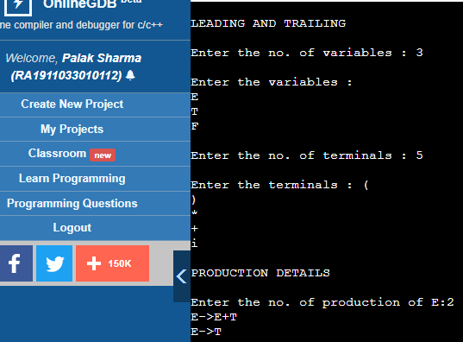

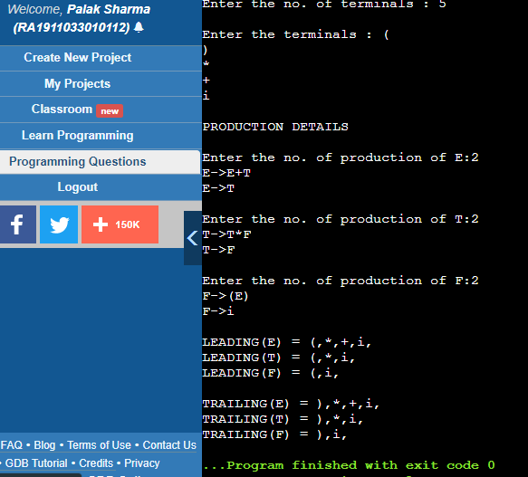

**RESULT :**

The program was successfully compiled and run.

# 

**Palak Sharma**

**RA1911033010112**

**EXP 9**

**Computation of LR(0) Items**

**AIM :** A program to implement LR(0) items

**ALGORITHM :**

1. Start.
2. Create structure for production with LHS and RHS.
3. Open file and read input from file.
4. Build state 0 from extra grammar Law S' -> S $ that is all start symbol of grammar and one Dot ( . ) before S symbol.
5. If Dot symbol is before a non-terminal, add grammar laws that this non-terminal is in Left Hand Side of that Law and set Dot in before of first part of Right Hand Side.
6. If state exists (a state with this Laws and same Dot position), use that instead.
7. Now find set of terminals and non-terminals in which Dot exist in before.
8. If step 7 Set is non-empty go to 9, else go to 10.
9. For each terminal/non-terminal in set step 7 create new state by using all grammar law that Dot position is before of that terminal/non-terminal in reference state by increasing Dot point to next part in Right Hand Side of that laws.
10. Go to step 5.
11. End of state building.
12. Display the output.
13. End.

**Program:**

#include<iostream.h>

#include<conio.h>

#include<string.h>

char prod[20][20],listofvar[26]="ABCDEFGHIJKLMNOPQR"; int novar=1,i=0,j=0,k=0,n=0,m=0,arr[30];

int noitem=0;

struct Grammar

{

char lhs;

char rhs[8];

}g[20],item[20],clos[20][10];

int isvariable(char variable)

{

for(int i=0;i<novar;i++)

if(g[i].lhs==variable)

return i+1;

return 0;

}

void findclosure(int z, char a)

{

int n=0,i=0,j=0,k=0,l=0;

for(i=0;i<arr[z];i++)

{

for(j=0;j<strlen(clos[z][i].rhs);j++)

{

if(clos[z][i].rhs[j]=='.' && clos[z][i].rhs[j+1]==a)

{

clos[noitem][n].lhs=clos[z][i].lhs;

strcpy(clos[noitem][n].rhs,clos[z][i].rhs);

char temp=clos[noitem][n].rhs[j];

clos[noitem][n].rhs[j]=clos[noitem][n].rhs[j+1];

clos[noitem][n].rhs[j+1]=temp;

n=n+1;

}

}

}

for(i=0;i<n;i++)

{

for(j=0;j<strlen(clos[noitem][i].rhs);j++)

{

if(clos[noitem][i].rhs[j]=='.' && isvariable(clos[noitem][i].rhs[j+1])>0)

{

for(k=0;k<novar;k++)

{

if(clos[noitem][i].rhs[j+1]==clos[0][k].lhs)

{

for(l=0;l<n;l++)

if(clos[noitem][l].lhs==clos[0][k].lhs &&

strcmp(clos[noitem][l].rhs,clos[0][k].rhs)==0)

break;

if(l==n)

{

clos[noitem][n].lhs=clos[0][k].lhs;

strcpy(clos[noitem][n].rhs,clos[0][k].rhs);

n=n+1;

}

}

}

}

}

}

arr[noitem]=n;

int flag=0;

for(i=0;i<noitem;i++)

{

if(arr[i]==n)

{

for(j=0;j<arr[i];j++)

{

int c=0;

for(k=0;k<arr[i];k++)

if(clos[noitem][k].lhs==clos[i][k].lhs && strcmp(clos[noitem][k].rhs,clos[i][k].rhs)==0)

c=c+1;

if(c==arr[i])

{

flag=1;

goto exit;

}

}

}

}

exit:;

if(flag==0)

arr[noitem++]=n;

}

void main()

{

clrscr();

cout<<"ENTER THE PRODUCTIONS OF THE GRAMMAR(0 TO END) :\n";

do

{

cin>>prod[i++];

}while(strcmp(prod[i-1],"0")!=0);

for(n=0;n<i-1;n++)

{

m=0;

j=novar;

g[novar++].lhs=prod[n][0];

for(k=3;k<strlen(prod[n]);k++)

{

if(prod[n][k] != '|')

g[j].rhs[m++]=prod[n][k];

if(prod[n][k]=='|')

{

g[j].rhs[m]='\0';

m=0;

j=novar;

g[novar++].lhs=prod[n][0];

}

}

}

for(i=0;i<26;i++)

if(!isvariable(listofvar[i]))

break;

g[0].lhs=listofvar[i];

char temp[2]={g[1].lhs,'\0'};

strcat(g[0].rhs,temp);

cout<<"\n\n augumented grammar \n";

for(i=0;i<novar;i++)

cout<<endl<<g[i].lhs<<"->"<<g[i].rhs<<" ";

getch();

for(i=0;i<novar;i++)

{

clos[noitem][i].lhs=g[i].lhs;

strcpy(clos[noitem][i].rhs,g[i].rhs);

if(strcmp(clos[noitem][i].rhs,"ε")==0)

strcpy(clos[noitem][i].rhs,".");

else

{

for(int j=strlen(clos[noitem][i].rhs)+1;j>=0;j--) clos[noitem][i].rhs[j]=clos[noitem][i].rhs[j-1];

clos[noitem][i].rhs[0]='.';

}

}

arr[noitem++]=novar;

for(int z=0;z<noitem;z++)

{

char list[10];

int l=0;

for(j=0;j<arr[z];j++)

{

for(k=0;k<strlen(clos[z][j].rhs)-1;k++)

{

if(clos[z][j].rhs[k]=='.')

{

for(m=0;m<l;m++)

if(list[m]==clos[z][j].rhs[k+1])

break;

if(m==l)

list[l++]=clos[z][j].rhs[k+1];

}

}

}

for(int x=0;x<l;x++)

findclosure(z,list[x]);

}

cout<<"\n THE SET OF ITEMS ARE \n\n";

for(z=0;z<noitem;z++)

{

cout<<"\n I"<<z<<"\n\n";

for(j=0;j<arr[z];j++)

cout<<clos[z][j].lhs<<"->"<<clos[z][j].rhs<<"\n"; getch();

}

getch();

}

**OUTPUT :**

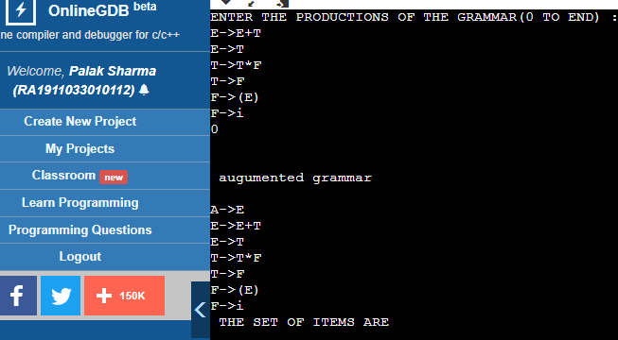

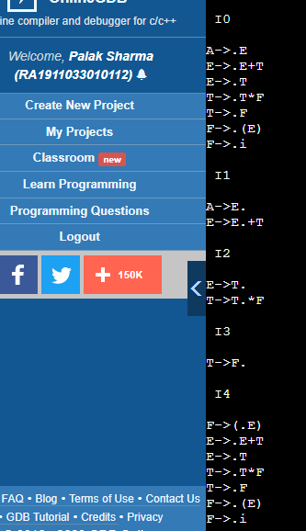

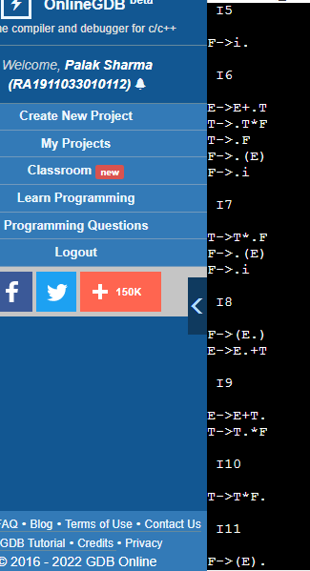

**RESULT :** The program was successfully compiled and run.

# 

**Palak Sharma**

**RA1911033010112**

**EXP 10**

# Intermediate code generation – Postfix, Prefix

**AIM :**

A program to implement Intermediate code generation – Postfix, Prefix.

# ALGORITHM :

1. Declare a set of operators.
2. Initialize an empty stack.
3. To convert INFIX to POSTFIX follow the following steps
4. Scan the infix expression from left to right.
5. If the scanned character is an operand, output it.
6. Else, If the precedence of the scanned operator is greater than the precedence of the operator in the stack(or the stack is empty or the stack contains a ‘(‘ ), push it.
7. Else, Pop all the operators from the stack which are greater than or equal to in precedence than that of the scanned operator. After doing that Push the scanned operator to the stack.
8. If the scanned character is an ‘(‘, push it to the stack.
9. If the scanned character is an ‘)’, pop the stack and output it until a ‘(‘ is encountered, and discard both the parenthesis.
10. Pop and output from the stack until it is not empty.
11. To convert INFIX to PREFIX follow the following steps
12. First, reverse the infix expression given in the problem.
13. Scan the expression from left to right.
14. Whenever the operands arrive, print them.
15. If the operator arrives and the stack is found to be empty, then simply push the operator into the stack.
16. Repeat steps 6 to 9 until the stack is empty

# CODE :

OPERATORS = set(['+', '-', '*', '/', '(', ')'])

PRI = {'+': 1, '-': 1, '*': 2, '/': 2}

### INFIX ===> POSTFIX ###

def infix_to_postfix(formula):

stack = [] # only pop when the coming op has priority

output = ''

for ch in formula:

if ch not in OPERATORS:

output += ch

elif ch == '(':

stack.append('(')

elif ch == ')':

while stack and stack[-1] != '(':

output += stack.pop()

stack.pop() # pop '('

else:

while stack and stack[-1] != '(' and PRI[ch] <= PRI[stack[-1]]:

output += stack.pop()

stack.append(ch)

# leftover

while stack:

output += stack.pop()

print(f'POSTFIX: {output}')

return output

### INFIX ===> PREFIX ###

def infix_to_prefix(formula):

op_stack = []

exp_stack = []

for ch in formula:

if not ch in OPERATORS:

exp_stack.append(ch)

elif ch == '(':

op_stack.append(ch)

elif ch == ')':

while op_stack[-1] != '(':

op = op_stack.pop()

a = exp_stack.pop()

b = exp_stack.pop()

exp_stack.append(op + b + a)

op_stack.pop() # pop '('

else:

while op_stack and op_stack[-1] != '(' and PRI[ch] <= PRI[op_stack[-1]]:

op = op_stack.pop()

a = exp_stack.pop()

b = exp_stack.pop()

exp_stack.append(op + b + a)

op_stack.append(ch)

# leftover

while op_stack:

op = op_stack.pop()

a = exp_stack.pop()

b = exp_stack.pop()

exp_stack.append(op + b + a)

print(f'PREFIX: {exp_stack[-1]}')

return exp_stack[-1]

expres = input("INPUT THE EXPRESSION: ")

pre = infix_to_prefix(expres)

pos = infix_to_postfix(expres)

# OUTPUT :

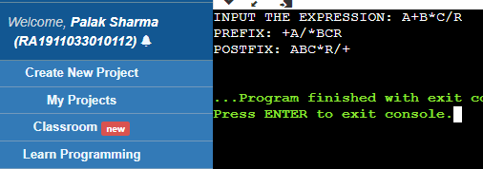

**RESULT :**

The program was successfully compiled and run.

# 

**Palak Sharma**

**RA1911033010112**

**EXP 11**

**Intermediate code generation – Quadruple, Triple, Indirect triple**

**AIM :** Intermediate code generation – Quadruple, Triple, Indirect triple

# ALGORITHM :

The algorithm takes a sequence of three-address statements as input. For each three address statements of the form a:= b op c perform the various actions. These are as follows:

1. Invoke a function getreg to find out the location L where the result of computation b op c should be stored.

1. Consult the address description for y to determine y'. If the value of y currently in memory and register both then prefer the register y' . If the value of y is not already in L then generate the instruction MOV y' , L to place a copy of y in L.
2. Generate the instruction OP z' , L where z' is used to show the current location of z. if z is in both then prefer a register to a memory location. Update the address descriptor of x to indicate that x is in location L. If x is in L then update its descriptor and remove x from all other descriptors.
3. If the current value of y or z have no next uses or not live on exit from the block or in register then alter the register descriptor to indicate that after execution of x : = y op z those register will no longer contain y or z.

**CODE :**

#include<stdio.h>

#include<ctype.h>

#include<stdlib.h>

#include<string.h>

void small();

void dove(int i);

int p[5]={0,1,2,3,4},c=1,i,k,l,m,pi;

char sw[5]={'=','-','+','/','*'},j[20],a[5],b[5],ch[2];

void main()

{

printf("Enter the expression:");

scanf("%s",j);

printf("\tThe Intermediate code is:\n");

small();

}

void dove(int i)

{

a[0]=b[0]='\0';

if(!isdigit(j[i+2])&&!isdigit(j[i-2]))

{

a[0]=j[i-1];

b[0]=j[i+1];

}

if(isdigit(j[i+2]))

{

a[0]=j[i-1];

b[0]='t';

b[1]=j[i+2];

}

if(isdigit(j[i-2]))

{

b[0]=j[i+1];

a[0]='t';

a[1]=j[i-2];

b[1]='\0';

}

if(isdigit(j[i+2]) &&isdigit(j[i-2]))

{

a[0]='t';

b[0]='t';

a[1]=j[i-2];

b[1]=j[i+2];

sprintf(ch,"%d",c);

j[i+2]=j[i-2]=ch[0];

}

if(j[i]=='*')

printf("\tt%d=%s*%s\n",c,a,b);

if(j[i]=='/')

printf("\tt%d=%s/%s\n",c,a,b);

if(j[i]=='+')

printf("\tt%d=%s+%s\n",c,a,b);if(j[i]=='-')

printf("\tt%d=%s-%s\n",c,a,b);

if(j[i]=='=')

printf("\t%c=t%d",j[i-1],--c);

sprintf(ch,"%d",c);

j[i]=ch[0];

c++;

small();

}

void small()

{

pi=0;l=0;

for(i=0;i<strlen(j);i++)

{

for(m=0;m<5;m++)

if(j[i]==sw[m])

if(pi<=p[m])

{

pi=p[m];

l=1;

k=i;

}

}

if(l==1)

dove(k);

else

exit(0);

}

# OUTPUT :

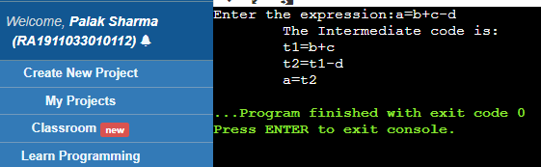

**RESULT :** The program was successfully compiled and run.

**Palak Sharma**

**RA1911033010112**

**EXP 12**

**Implementation of DAG**

**AIM :** A program to implement DAG.

# ALGORITHM :

1. The leaves of a graph are labeled by a unique identifier and that identifier can be variablenames or constants.

2. Interior nodes of the graph are labeled by an operator symbol.

3. Nodes are also given a sequence of identifiers for labels to store the computed value.

4. If y operand is undefined then create node(y).

5. If z operand is undefined then for case(i) create node(z).

6. For case(i), create node(OP) whose right child is node(z) and left child is node(y). 7. For case(ii), check whether there is node(OP) with one child node(y).

8. For case(iii), node n will be node(y).

9. For node(x) delete x from the list of identifiers. Append x to attached identifiers list forthe node n found in step 2. Finally set node(x) to n.

**CODE :**

#include<iostream>

#include<string>

#include<unordered_map>

using namespace std;

class DAG

{

public:

char label;

char data;

DAG* left;

DAG* right;

DAG(char x)

{

label='_';

data=x;

left=NULL;

right=NULL;

}

DAG(char lb, char x, DAG* lt, DAG* rt)

{

label=lb;

data=x;

left=lt;

right=rt;

}

};

int main()

{

int n;

n=3;

string st[n];

st[0]="A=x+y";

st[1]="B=A*z";

st[2]="C=B/x";

unordered_map<char, DAG*> labelDAGNode;

for(int i=0;i<3;i++)

{

string stTemp=st[i];

for(int j=0;j<5;j++)

{

char tempLabel = stTemp[0];

char tempLeft = stTemp[2];

char tempData = stTemp[3];

char tempRight = stTemp[4];

DAG* leftPtr;

DAG* rightPtr;

if(labelDAGNode.count(tempLeft) == 0)

{

leftPtr = new DAG(tempLeft);

}

else

{

leftPtr = labelDAGNode[tempLeft];

}

if(labelDAGNode.count(tempRight) == 0)

{

rightPtr = new DAG(tempRight);

}

else

{

rightPtr = labelDAGNode[tempRight];

}

DAG* nn = new DAG(tempLabel,tempData,leftPtr,rightPtr);

labelDAGNode.insert(make_pair(tempLabel,nn));

}

}

cout<<"Label ptr leftPtr rightPtr"<<endl;

for(int i=0;i<n;i++)

{

DAG* x=labelDAGNode[st[i][0]];

cout<<st[i][0]<<" "<<x->data<<" ";

if(x->left->label=='_')cout<<x->left->data;

else cout<<x->left->label;

cout<<" ";

if(x->right->label=='_')cout<<x->right->data;

else cout<<x->right->label;

cout<<endl;

}

return 0;

}

# OUTPUT :

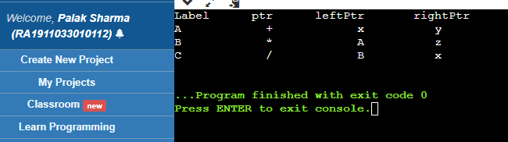

**RESULT :** The program was successfully compiled and run.

**Palak Sharma**

**RA1911033010112**

**EXP 13**

**Implementation of Anyone Storage SLO-2 Allocation Strategies**

**(heap,stack,static)**

**AIM :**

To implement various storage allocation techniques algorithms

# ALGORITHM :

Static storage allocation

● In static allocation, names are bound to storage locations.

● If memory is created at compile time then the memory will be created instaticarea and only once.

● Static allocation supports the dynamic data structure that means memory is created only at compile time and deallocated after program completion.

● The drawback with static storage allocation is that the size and position of dataobjects should be known at compile time.

● Another drawback is restriction of the recursion procedure. Stack Storage Allocation

● In static storage allocation, storage is organized as a stack.

● An activation record is pushed into the stack when activation begins and it is popped when the activation ends.

● Activation record contains the locals so that they are bound to fresh storage for each activation record. The value of locals is deleted when the activation ends.

● It works on the basis of last-in-first-out (LIFO) and this allocation supports the recursion process. Heap Storage Allocation.

● Heap allocation is the most flexible allocation scheme.

● Allocation and deallocation of memory can be done at any time and at any place depending upon the user's requirement.

● Heap allocation is used to allocate memory to the variables dynamically and when the variables are no more used then claim it back.

● Heap storage allocation supports the recursion process.

**CODE :**

class memory_allocation:

def create_instance_memory_blocks(self,l):

self.i=0

self.block=l

self.pdict ={}

for self.y in self.block:

print("Memory block :{0} | Size: {1}".format(self.i,self.y))

self.i+=1

self.pdict[self.y]=0

print("Total {0} Memory blocks Created!".format(self.i))

def process_to_be_allocated(self,list):

self.total_processlist=list

print()

self.i=0

self.bdict={}

for self.x in self.total_processlist:

print("Process :{0} | Size: {1}".format(self.i,self.x))

self.bdict[self.x]=0

self.i+=1

print("Total {0} Processes needs to be allocated".format(self.i))

def first_fit(self):

print()

print("Using First Fit Algorithm")

self.i=0

for self.x in self.total_processlist:

self.j=0

for self.y in self.block:

if (self.x <= self.y) and (self.pdict[self.y]!=1):

self.pdict[self.y]=1

self.bdict[self.x]=1

print("Process :{0} |Size :{1} allocated into Memory block :{2} |Size :{3}".format(self.i,self.x,self.j,self.y))

break

self.j+=1

self.i+=1

def worst_fit(self):

print()

print("Using worst Fit Algorithm")

self.i=0

for self.x in self.total_processlist:

self.j=0

for self.y in self.block:

if (self.x <= self.y) and (self.pdict[self.y]!=1):

if(self.isbiggest(self.y)):

self.pdict[self.y]=1

self.bdict[self.x]=1

print("Process :{0} |Size :{1} allocated into Memory block :{2} |Size :{3}".format(self.i,self.x,self.j,self.y))

break

self.j+=1

self.i+=1

def best_fit(self):

print()

print("Using best Fit Algorithm")

self.i=0

for self.x in self.total_processlist:

self.j=0

for self.y in self.block:

if (self.x <= self.y) and (self.pdict[self.y]!=1):

if(self.issmallest(self.y)):

self.pdict[self.y]=1

self.bdict[self.x]=1

print("Process :{0} |Size :{1} allocated into Memory block :{2} |Size :{3}".format(self.i,self.x,self.j,self.y))

break

self.j+=1

self.i+=1

def issmallest(self,x1):

self.flag =True

self.x1=x1

for self.y1 in self.block:

if self.y1<self.x1 and self.pdict[self.y1]!=1 and self.y1>=self.x:

self.flag=False

return self.flag

def isbiggest(self,x1):

self.flag =True

self.x1=x1

for self.y1 in self.block:

if self.y1>self.x1 and self.pdict[self.y1]!=1:

self.flag=False

return self.flag

def unallocated_processes(self):

print()

self.i=0

for self.x in self.total_processlist:

if (self.bdict[self.x]!=1):

print("Process :{0} |Size :{1} Unallocated! ".format(self.i,self.x))

self.i+=1

def unallocated_blocks(self):

print()

self.j=0

for self.y in self.block:

if (self.pdict[self.y]!=1):

print("Memory block :{0} |Size :{1} Empty! ".format(self.j,self.y))

self.j+=1

def memory_utilization(self):

self.total = 0

self.sum=0

for self.z in self.total_processlist:

if self.bdict[self.z]!=0:

self.sum = self.sum + self.z

for self.z in self.block:

self.total = self.total + self.z

print("Total Memory Utilization = {0:.2f}%".format(self.sum*100/self.total))

if __name__ == '__main__':

bl = [100,500,200,300,600]

pl = [212,417,112,426]

print("First Fit Instance")

obj = memory_allocation()

obj.create_instance_memory_blocks(bl)

obj.process_to_be_allocated(pl)

obj.first_fit()

obj.unallocated_processes()

obj.unallocated_blocks()

obj.memory_utilization()

print()

print("Worst Fit Instance")

obj1 = memory_allocation()

obj1.create_instance_memory_blocks(bl)

obj1.process_to_be_allocated(pl)

obj1.worst_fit()

obj1.unallocated_processes()

obj1.unallocated_blocks()

obj1.memory_utilization()

print()

print("Best Fit Instance")

obj2 = memory_allocation()

obj2.create_instance_memory_blocks(bl)

obj2.process_to_be_allocated(pl)

obj2.best_fit()

obj2.unallocated_processes()

obj2.unallocated_blocks()

obj2.memory_utilization()

# OUTPUT :

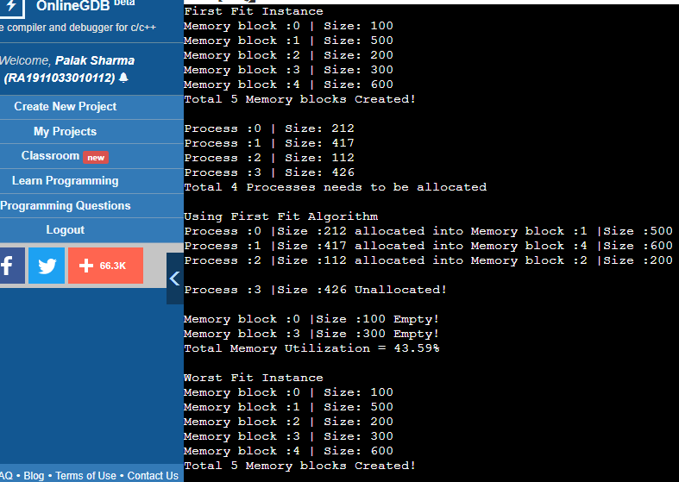

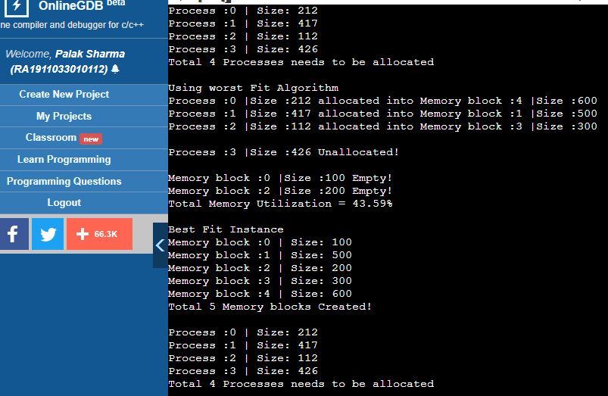

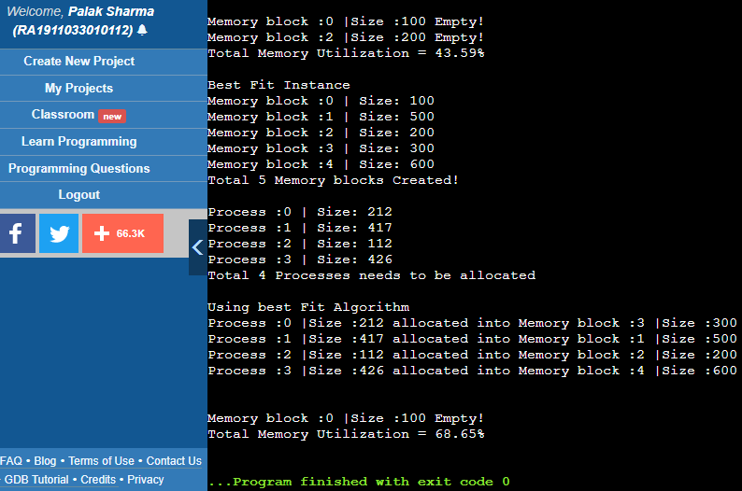

**RESULT :** The program was successfully compiled and run.